





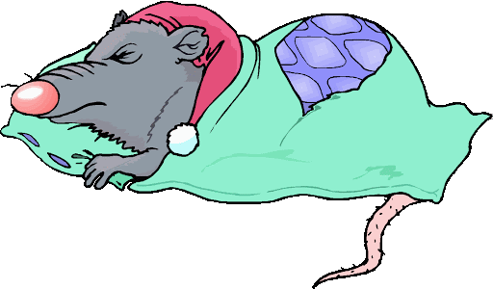

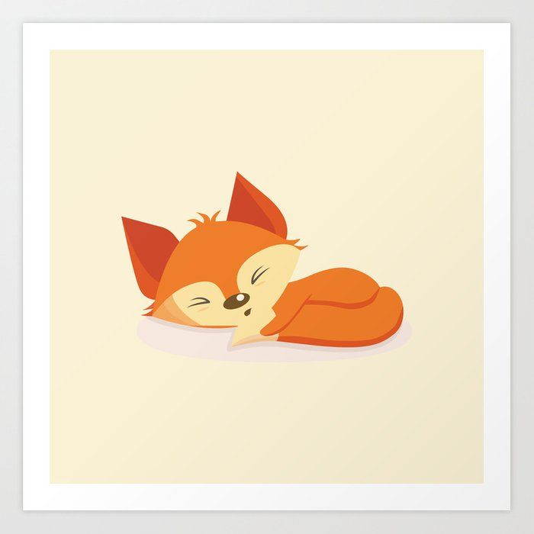

fox in a box.

dog on a log.

rat in a hat.

bug in a rug.

I am snug with ted in bed.

**Speed digraph sounds to revise:**

sh ch th ng nk qu

***Before you start? Do you know the speed sounds and tricky words? I need to read this with confidence.***

**Learn these red words before reading. (You may want to cut them up to play games with and practise).**

**I**