COMPETITION RESULTS 2018-19
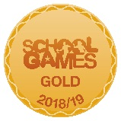

AUTUMN 2018 | SPRING 2019 | SUMMER 2019
Rugby – Year 4  2nd | Fencing – Year 4  2nd | Football – A team – 1st
Football – Year 3  1st | Dodge Ball  2nd | Hand Ball – Year 3  2nd
Indoor Athletics – Year 3/ 4 -3rd | Skipping – Year 2  Gold – Best team | Skipping – Year 4  2nd Overall  2 Gold, 5 Silver, 4 Bronze awards
Tennis – Year 4 - 2nd |  | Handball – Year 3 - 2nd
 |  | Gymnastics – Year 4 - 2nd
 |  | Cricket – Year 4 - 1st

