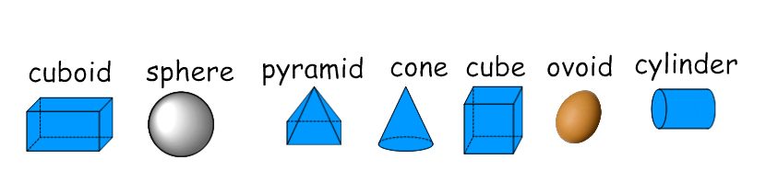

flat face

curved face

**Venn diagram: 3D shapes**

**Venn diagram: 2D shapes**

Make your own Venn diagram for 2D shapes. You may like to think about shape names, colour, number of sides or lines of symmetry. Label each section of the Venn diagram and place at least eight shapes according to your rules.

