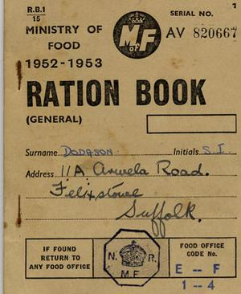
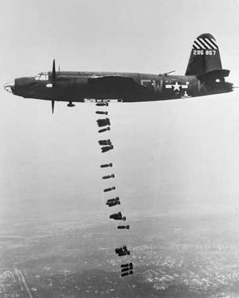
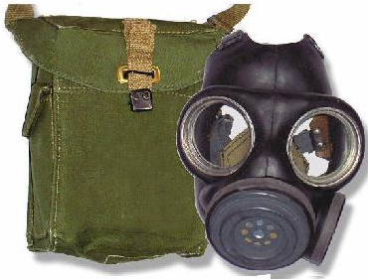
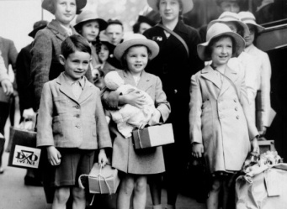
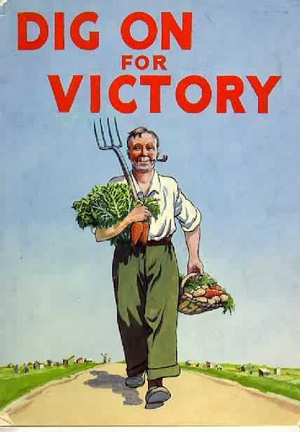

Name:

Contents

1.
2.
3.
4.
5.
6.
7.
8.
9.
10.
11.
12.
13.
14.
15.
16.
17.
18.
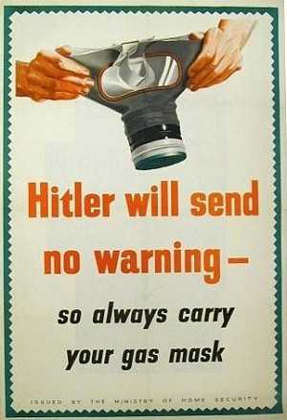
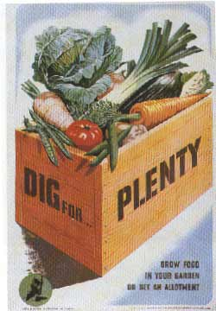
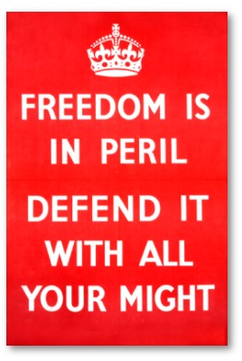
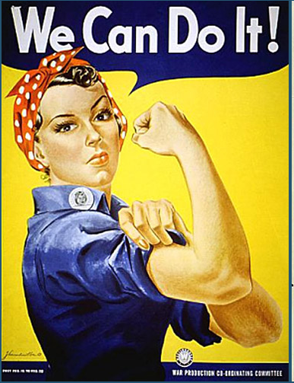
World War 2 Posters

Look at the WW2 propaganda poster and answer the questions, think about the adverts that you have learnt about in literacy this term.

What do you think this poster is trying to get people to do?
............................................................................................................................................................................................................................................................................................................................................................

Why do you think this needs to be done?
............................................................................................................................................................................................................................................................................................................................................................

What features of an advert does it use?
............................................................................................................................................................................................................................................................................................................................................................

Who is the poster aimed at?
............................................................................................................................................................................................................................................................................................................................................................
Why is this poster effective?
............................................................................................................................................................................................................................................................................................................................................................
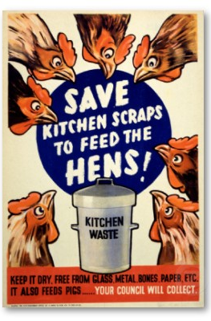
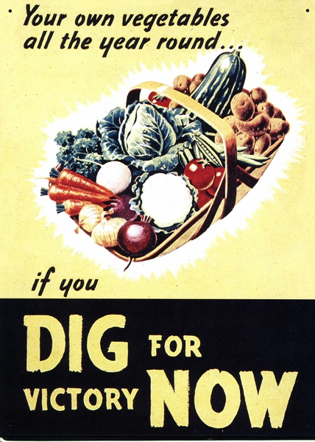
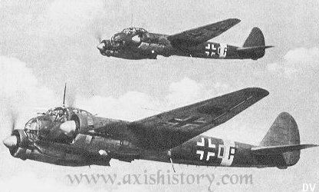
The Blitz

Fill in the letter about the Blitz using the word bank below.

Dear Diary,
When I hear the _________________ I feel
extremely ______________. We have to run as fast as we
can to the __________. When we’re there we hear the
______ from the planes falling and pray they won’t
_______ near or on us! My __________ is fighting in
France and I feel __________ that he might not come
back. We spend the whole _______ in the shelter
sometimes I really hope the _________ of London stops
soon!
Love from _________.

Word bank:
frightened explode sirens scared
shelter father Blitz bombs night

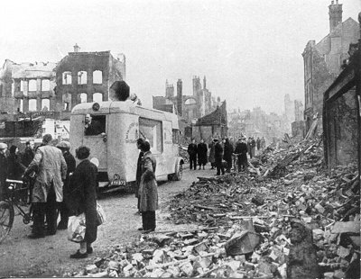
The Blitz

On the next page use exciting adjectives and adverbs to improve our descriptive writing. Copy the piece of writing adding in the extra words and sentence endings.

It was a * night. There were * bombs dropping. David could hear the * siren wailing and… He held his mum’s hand # as they hurried to shelters #. The sky was full of * planes and the * searchlights. David looked around him. He could see… As they rushed through the * city David felt… It was *. He could smell…

* = ADJECTIVE (describing word e.g. bright, loud)
# = ADVERB (the describing HOW something is happening e.g. quickly, carefully)
… = continue this sentence

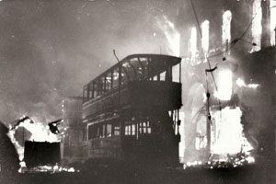
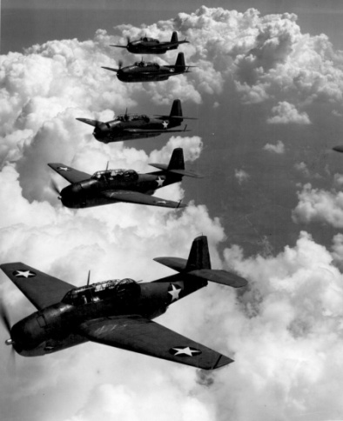

_____________________________________________________________________________________________________________________________________________________________________________________________________________________________________________________________________________________________________________________________________________________________________________________________________________________________________________________________________________________________________________________________________________________________________________________________________________________________________________________________________________________________________________________________________________________________________________________________________________________________________________________________________________________________________________________________

Thursday 2.9.1940

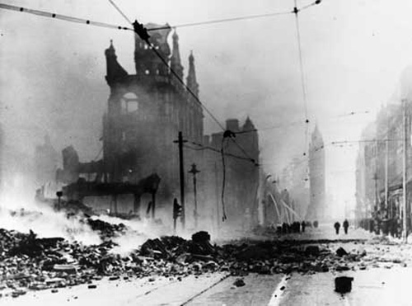

Clothing Rationing

Along with food clothing was also rationed during World War 2, although not right at the start of the war unlike food. Each adult and child had 48 coupons to spend each year and the clothes that they brought had to last as long as they could manage.
ITEM | Number of Coupons- Men | Number of Coupons- Women | Number of Coupons- Children
Raincoat | 16 | 15 | 11
Overcoat | 7 | 7 | 4
Jacket | 13 | 12 | 8
Shirt/Blouse | 5 | 4 | 3
Jumper/Cardigan | 5 | 5 | 3
Trousers | 8 | 8 | 6
Shorts | 3 | 3 | 2
Skirt |  | 8 | 6
Boots/Shoes | 7 | 5 | 3
Nightdress/Pyjamas | 8 | 6 | 6
Underpants/Knickers/Vest | 3 | 3 | 2
Socks/ Stockings | 2 | 2 | 1
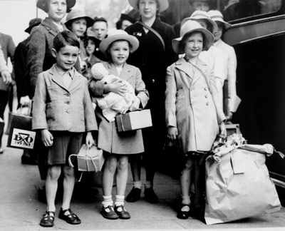

Spending your rations
Imagine: Your house has been bombed and you have nothing left. You are about to be evacuated and you have to buy enough clothes to take with you; they need to last you as long as possible.
You have only 48 coupons! Will you have enough?

What do you need to buy? How many coupons do you have to hand over?

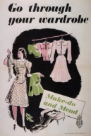
How many more will you need?
Did you have enough coupons?

World War 2 Quiz

Answer the questions by circling True or False.
If you need help answering the questions use the topic resource books to help you.

Children were evacuated from the countryside to the towns.
The operation organised by the government to evacuate children was called ‘Operation Pied Piper’.
Everyone had to carry a gas mask.
There were food shortages because supply ships were torpedoed.
Men, women, and children were given ration books for food.
Bananas and oranges were easily obtainable.
Clothing was rationed from the beginning of the war.
Women who worked on farms were called Land Girls.
Women who worked in factories were paid more than men.
The Home Guard was formed because there was fear from invasion.
Most of the men in the Home Guard were over 40.

