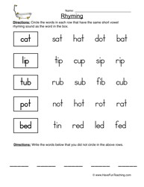

Can you name any other words that rhyme?

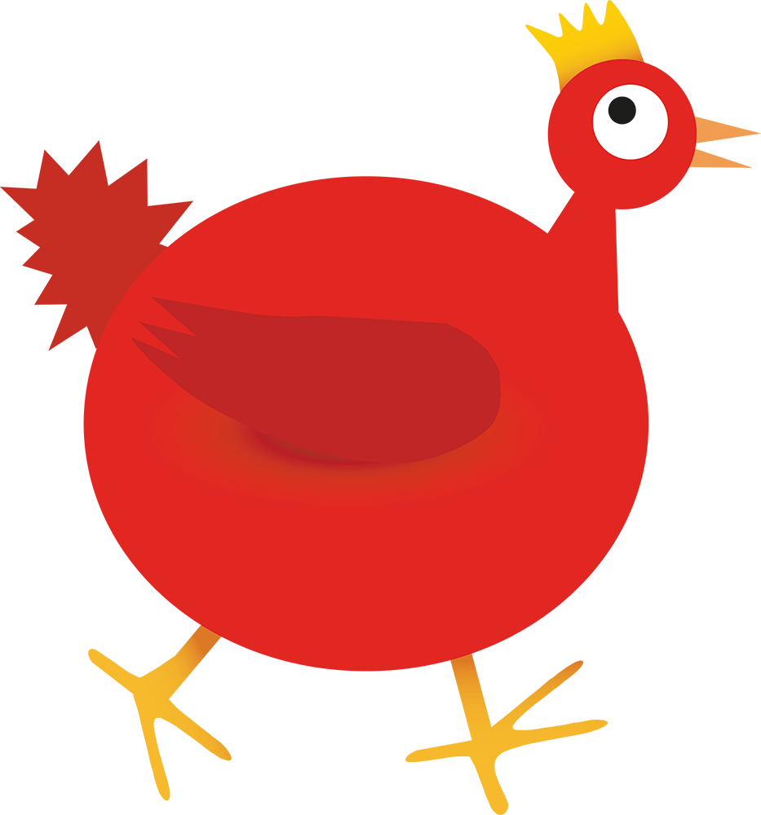

Over the past few weeks we have been developing early literacy concepts such as rhyme and rhythm.

We have learnt and continue to learn a number of nursery rhymes.

We have performed The Little Red Hen rap.

We’ve changed the words in the rap to invent a new one.

Try the attached sheet with your child to see if they can spot any rhyming words.

You will have to read it to them so they can hear the rhyme as it is too early days for some children to read these words.

**Top Tip!**

**Say the first word then the word you want to check e.g.**

**Cat sat, cat sat, cat sat cat, sat. Does that rhyme?**

**Cat hat, cat hat, cat hat. Does that rhyme?**

**Try joining in with your child as they perform ‘The Little Red Hen Rap’**

*‘Little Red Hen, Little Red Hen,*

*Whose gonna help that little red hen.*

*I’ve asked before and I’ll ask again,*

*Whose gonna help that little red hen?’*



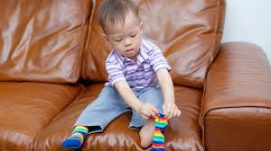

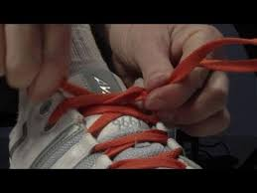

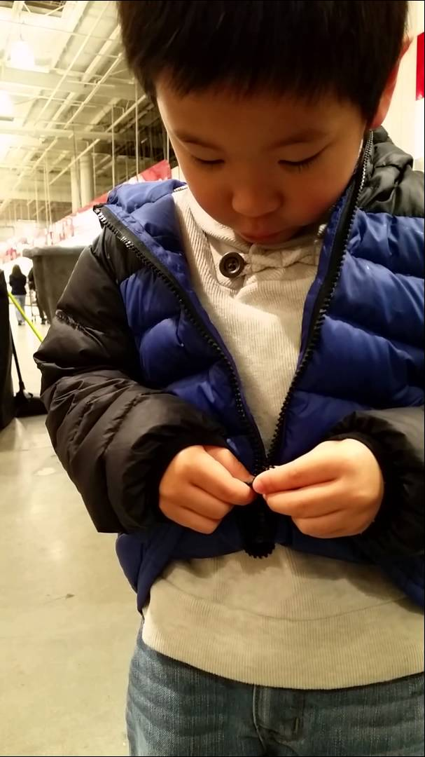



Zipping Up. It is important for our children to be able to zip up their coats to ensure they feel independent and successful. Therefore, as winter approaches and children get their new warm coats encouraging and teaching alongside us on this aspect would be a great partnership.

This is also great for their self-confidence and awareness (a prime area of learning) and will give us good evidence for **an exceeding judgment** in this area alongside buttons and fastenings as well as ensuring your child is making good progress from their starting points.

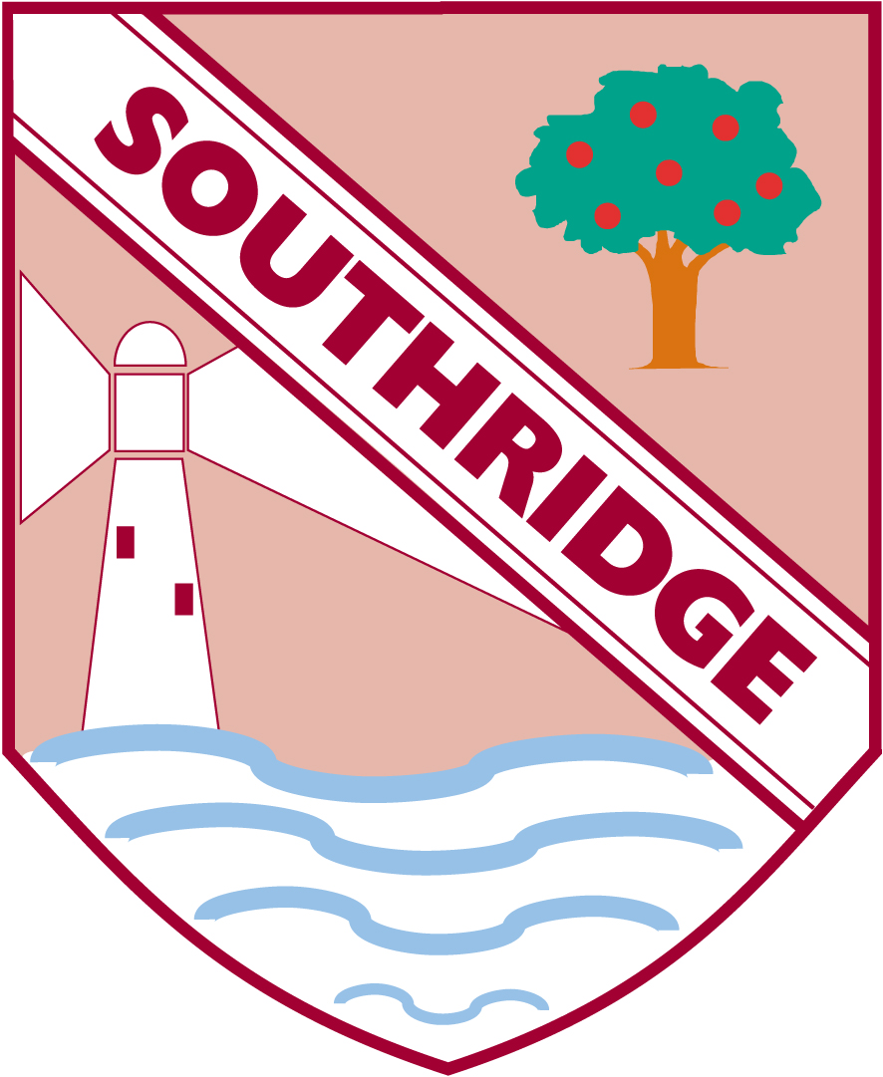

**Reception Newsletter 12th October 2018**