The crow sat high in the tree.

She was sad.

The snow fell slow and lay below.

The wind began to blow.

Brrrrrrrrrrr

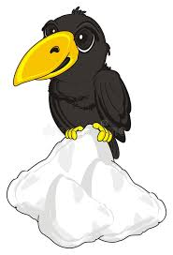

***Before you start? Do you know the speed sounds and tricky words. I need to read this with confidence.***

**Learn these red words before reading. (You may want to cut them up to play games with and practise).**

the she was be

**Speed digraph sounds to revise** :

ch sh th ng nk ay ee igh ow