Fruity Ice Cream Bread
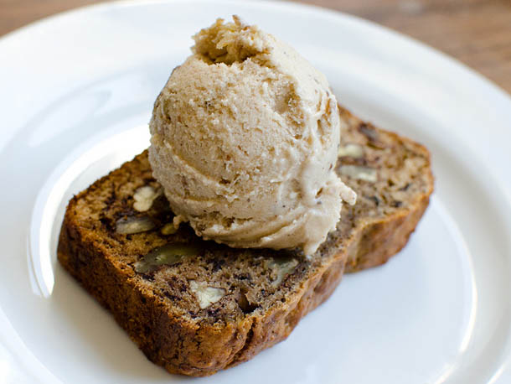
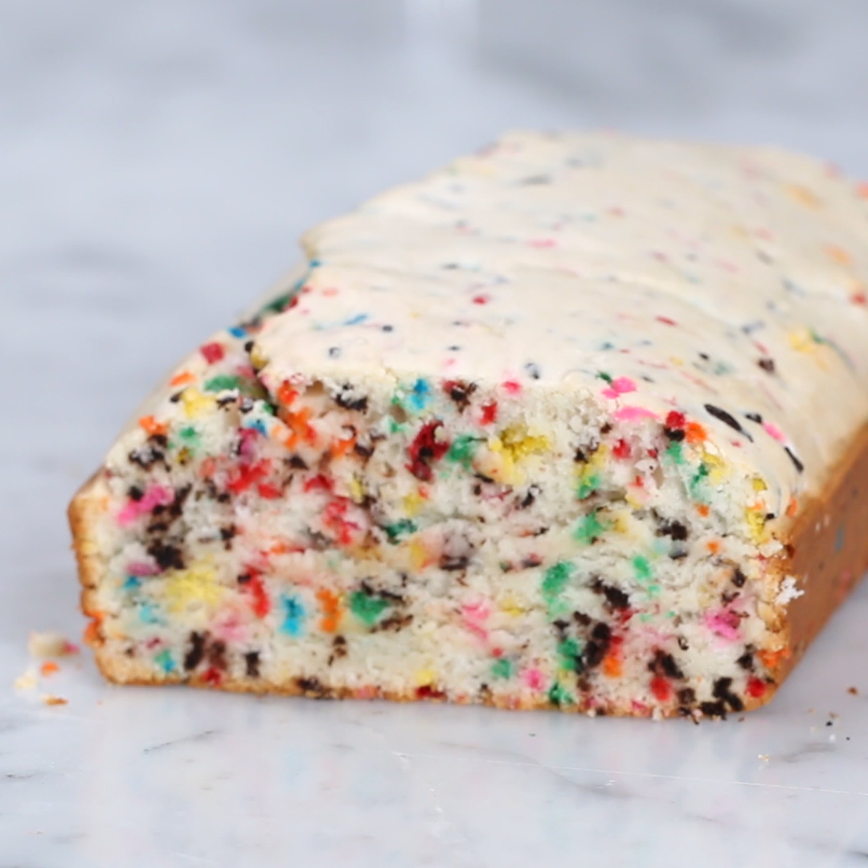
1 ½ cups of a strong flavoured ice cream, ¾ cup of self-raising flour, mixed fruit

Before the children begin their work…..
Preheat the oven to 350 F.
Remove the ice cream from the freezer and allow it to soften slightly.

Actions for Little Cooks on the Snack Team

- Grease a round baking tin.

- Put the ice cream and flour into a bowl.

- Mix together until smooth. Add a little more ice cream if necessary until a thick creamy batter is formed. Stir in a handful of mixed fruit.

- Put into the cake tin or loaf and bake for 25 to 30 minutes. Check to see if it is cooked before turning out onto a cooling rack.

- When cool cut into wedges or slices.

- Serve slices on a plate with a scraping of butter or in a dish with a teaspoon of ice cream and a squirt of ice-cream sauce.

