Southridge First School Reception Newsletter 21.12.18



Warmest Christmas wishes to you all from the Reception Team

We know Christmas can be a hard time to manage the excitement of little ones so we wanted to share with you a few top tips that they already know.

* Peer massage to the song of I hear thunder

(They can do this with brothers or sisters or you).

It’s a shared experience of breathing in through your nose and out from your mouth, as if blowing a feather, which keeps breathing under control.

* Mindfulness: To cope with those sleepless nights try getting the children to put their hands on their tummies (make the picnic table) close their eyes and breathe in and out for a minute. It helps if you do this too.
* At bedtime another good calmer, mindfulness strategy is to place their favourite teddy or bed time toy on their tummies in bed and watch it as they use the same breathing techniques and focus on the toy’s rise and fall.

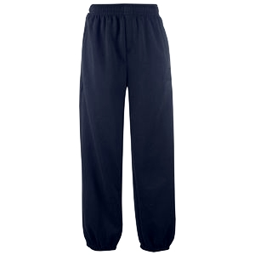

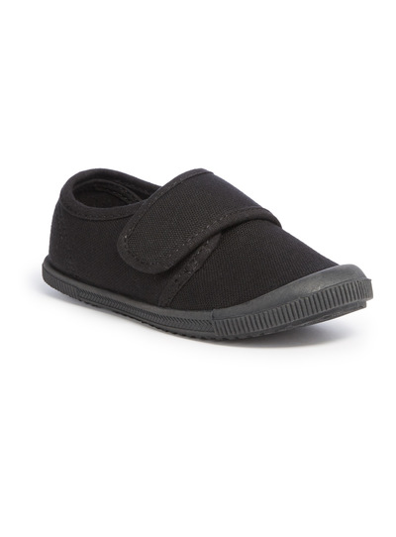

We have sent PE bags home this week. Can we ask you to check that your child’s shoes still fit and ensure there is a pair of track suit bottoms in the bag when they return to school to keep them warm during outdoor P.E. Thank you.



We have collected reading material in for auditing but do not despair! We have set a fun and quirky reading challenge for you to work through over Christmas. See attached.





At his point in the year all children are naturally tired but have done you all proud in their trips and Christmas performance. Behaviour has been very good when we have been out and about, so a huge credit to you all.