

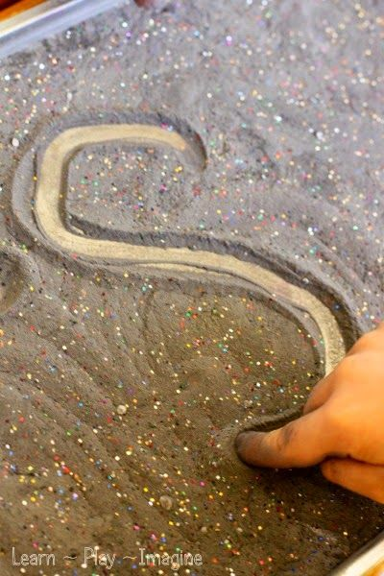

Parent consultations.

It was good to have the opportunity to catch up with parents/carers on Monday. The outcomes for children are always better when teachers and parents work together in partnership. We look forward to seeing the rest of you on Tuesday 6th November to discuss how your child has settled.

Can we take this opportunity to thank you for your input so far, especially with your contributions to learning journals. And finally, thank you for your kind words which are much appreciated.

**What a busy week we have had in Reception!**

Most days we found den building outside tricky but that didn’t stop us! The weather gave us the opportunity to test different materials when building dens/houses/shelters in the large construction area. We also made the most of the windy weather by flying ribbons and fabric. We have been writing in glitter on large surfaces and using our big outdoor voices when playing with the dinosaurs in the outdoor small world area. We’ve looked for bugs in the garden and checked for changes in the pond. We have loved getting messy and spray painting on the big screens. We even enjoyed the cleaning up part with brushes and the soapy water! We really have had a super half term together, your children have been brilliant but it is time for the children and adults of Reception to rest and enjoy time with our families. We hope you all have a lovely half term break and we will look forward to seeing you all again on Monday 5th November.

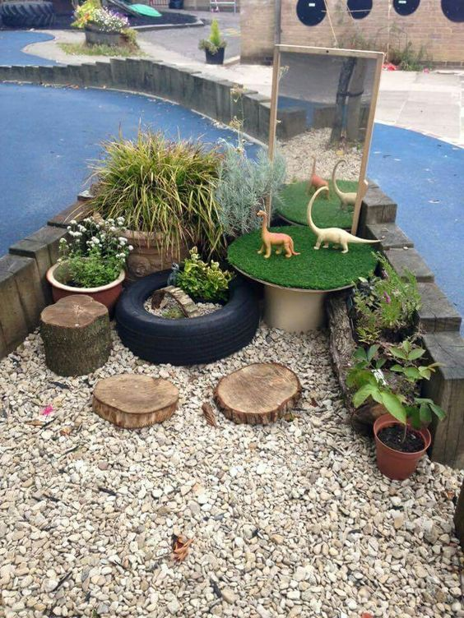



**Reception Newsletter 26th October 2018**