Monday 20th April

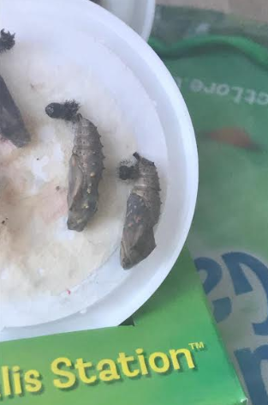

Well, before the Easter Holidays each of our 16 caterpillars were snuggled in their own chrysalis and beginning to transform into butterflies.

Two of our Year 1 staff, Ms Benford and Miss Cassidy, kindly agreed to take care of our insect friends over the holiday. They did a brilliant job!

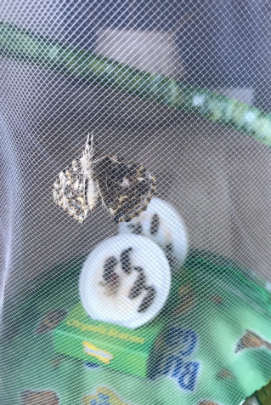

The Reception Team have been kept updated on their progress over the holidays. Below are photographs of our butterfly friends being released and there are videos on Reception’s Home Learning page (week 3) to watch.

We would like to say a HUGE thank you to Ms Benford’s children Eva and Charlie, and Ms Cassidy’s little girl Grace for looking after our beautiful butterflies and releasing them into the world!



Miss Cassidy’s daughter Grace took great care of her set of butterflies. She loved her job of looking after them, always making sure that they were fed and happy. We are really proud of Grace and think she has been incredibly kind, responsible and a great friend to Reception. Well done Grace!

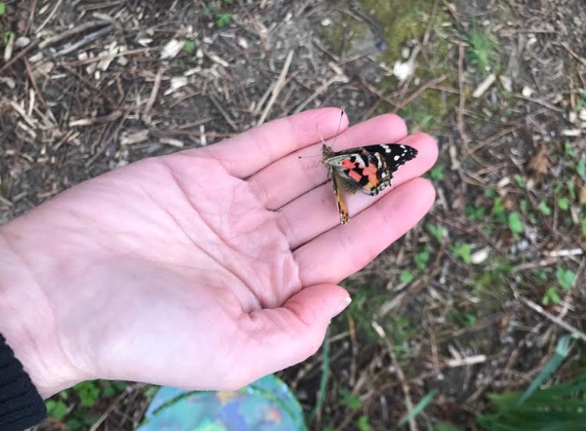 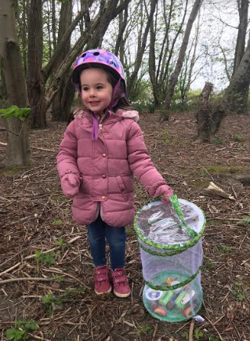

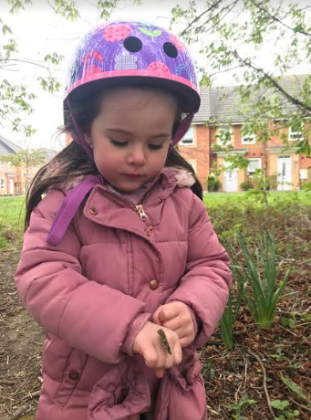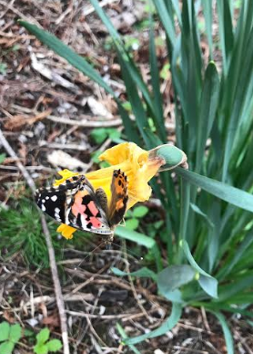

Ms Benford’s children, Eva and Charlie, took wonderful care of the second set of butterflies. They did such a good job that one of the butterflies came back the next morning and joined them for breakfast, nibbling on a piece of orange!

