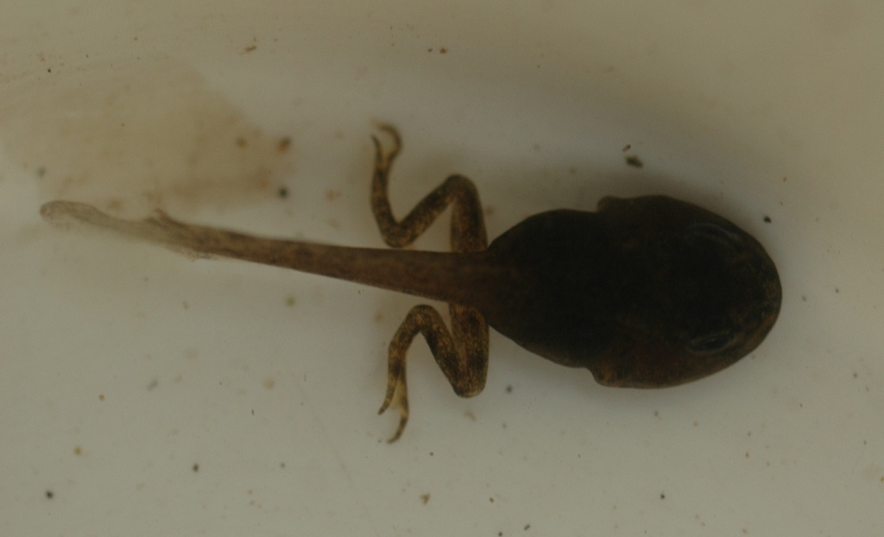

Coming Up!

Can your child bring a yogurt pot or a small plastic bottle to school next week please as we will be making musical instruments.

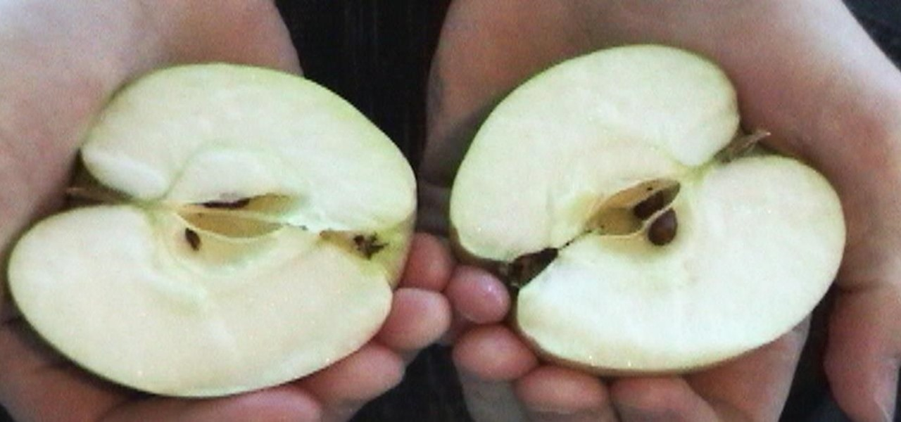

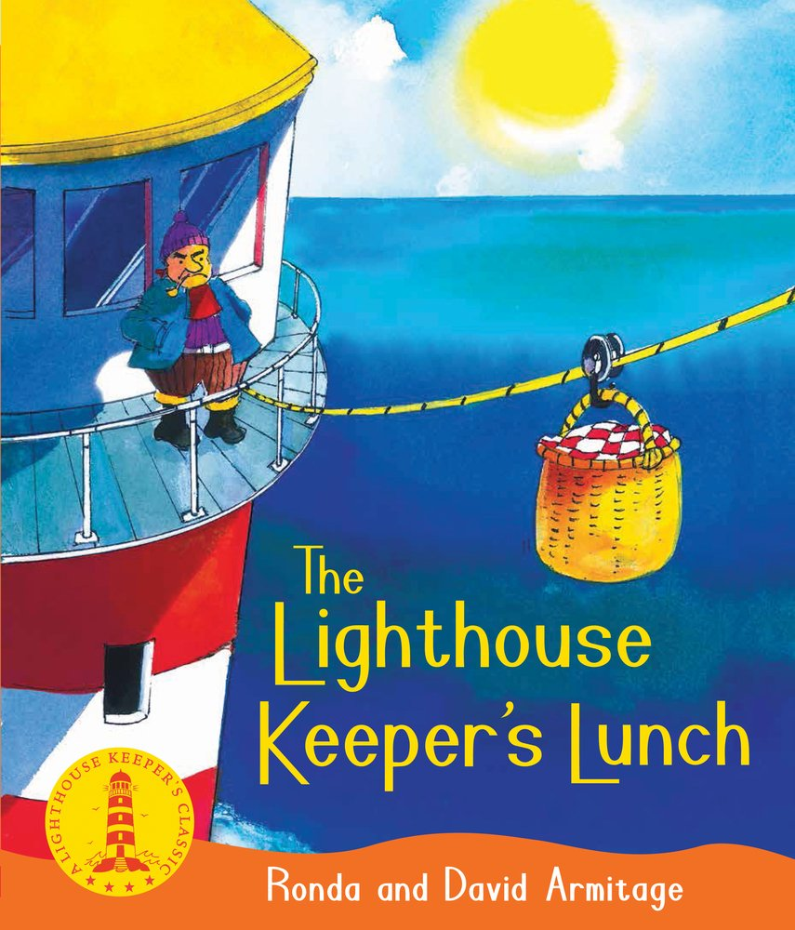

Maths.

In numeracy we have been thinking about ‘finding half’ and there has been lots of lovely maths talk e.g. fair, share, half, equal, even, divide, amount, whole, part.

At Home.

To consolidate this learning, maybe you could encourage your child to halve a set of toys or share some snacks between two people. Make sure children count to check they have shared fairly and that there is an equal amount on both sides.

Literacy.

In literacy we’ve been reading and writing about all the bother that Mr and Mrs Grinling had with the seagulls in The Lighthouse Keeper’s Lunch. Children will be able to tell you all about the pesky seagulls and Mr and Mrs Grinling’s ingenious plan. Find attached some of the characters from the story to make stick puppets with at home. If you don’t have the story at home you can find it at [www.youtube.com/watch?v=46wCRq50Wwg](http://www.youtube.com/watch?v=46wCRq50Wwg)

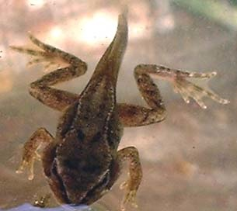

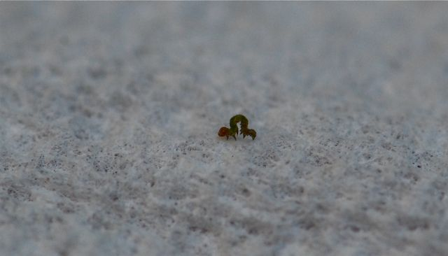

Welcome back!

It was lovely to welcome the children back into school for the start of our summer term - and what an exciting start it has been. While we were on holiday Mrs Mason’s tadpoles have grown back legs and Miss Parker has frogs in her class! Also, some tiny eggs arrived which had caterpillars inside and we’ve watched them grow bigger and bigger each day!

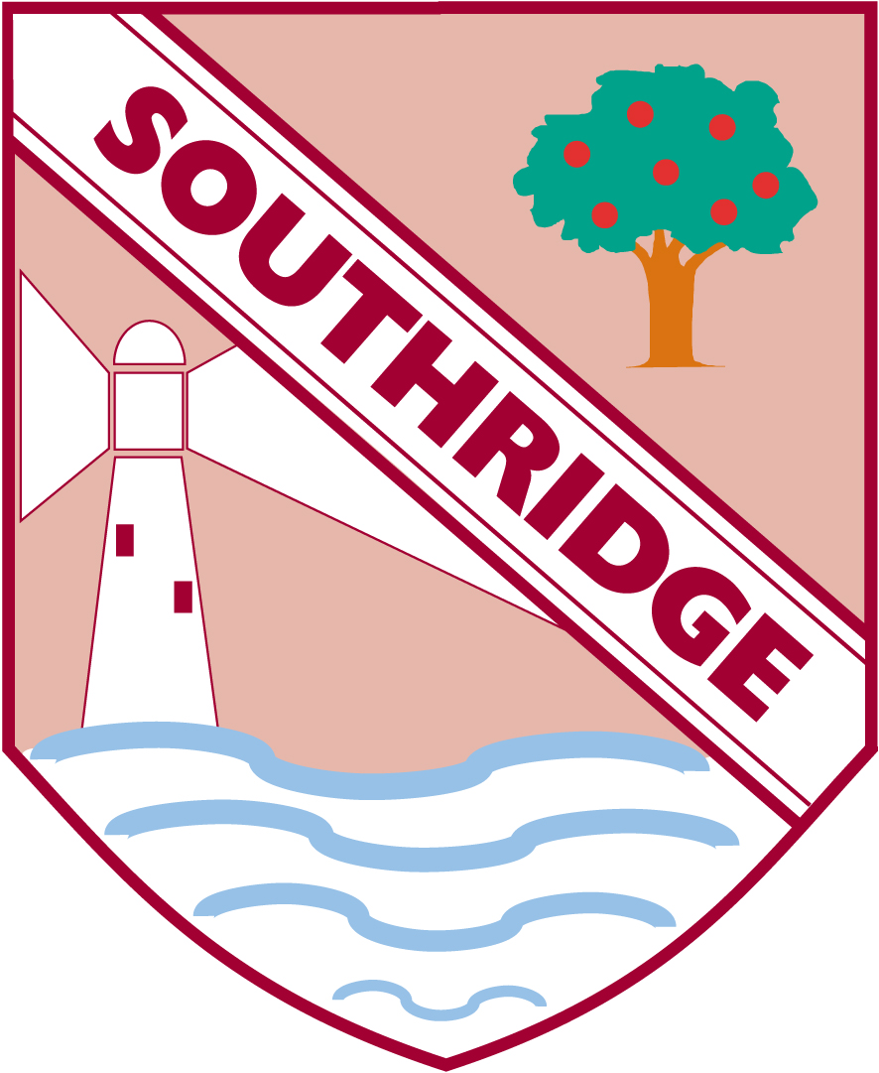

Southridge First School

Reception Newsletter 26.4.19