

What an exciting week this has been!

Welcoming the beginning of December means the cheeky elves are back in school and surprising us every day with their antics. We’ve been putting up the Christmas decorations, practising for our Christmas performance, preparing for party day AND looking forward to a REAL REINDEER visiting our Christmas fair!

Reception Newsletter 6.12.18

**Party/ Panto Day – Monday 10th December.**

**Please check bags for party tea picnic bag!**

Thank you to those who have offered to help at the pantomime, you should have received a risk assessment and we would be grateful if you could take a minute or two to read through it before Monday. Due to cost of the coach we have to ask parents to meet us at the Play House at 9.20am. Parents usually car share on these occasions. If there are any problems with this please let us know in advance. We look forward to seeing you there.

**Christmas Performance Reminder**

**Friday 14th 9.30 am and 2.00 pm.**

Thank you to those who have sent in costumes already. It really helps us to get organised.

Can we please ask parents with babies or toddlers to sit in the side seats or at the back of the hall in order to assist a quick escape should little ones become fractious during the performance.



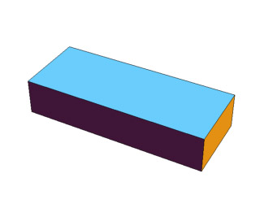







3D Shapes.

We’ve been learning about 3D shapes this week and looking closely at their properties e.g. the shape of their faces, how many point/sides they have. We’ve also been noticing 3D shapes all around us at school.

Maybe you and your child could look out for 3D shapes this weekend and send us some pictures or draw them on the attached sheet.