Day | 9-9.30 | 9.30-10.30 | 10.30 | 10.45-11.15 |  | 11.30 | Lunch | 1.00-1.30 | 1.30-2.30 | 2.30-300
M | Phonics with Miss Parker lesson 1 | Physical Education/ Speed and agility.  Grown-ups. Put lots of objects such as balls or bean bags even toys out all over the garden area. Children have to run and collect an item come back and put in into a basket then run for the next one. To challenge, time it? to make it fun, Can they complete before their favourite piece of music ends. | Story time and milk  ‘Mrs Armitage on Wheels’ | Make a number line game to 30 with your grown-ups.. Choose different things to happen on different numbers. E.g if you land on a monster go back one less.  Play it with your brother sisters or family on face time. |  | Counting to 100 by 1’s  https://www.youtube.com/watch?v=QbHobZOKY5w  counting backwards in 1 s  https://www.youtube.com/watch?v=v82X6XhsQhs |  | Writing: Seagull Speech Bubbles.  Write what you think the seagulls are saying. Don’t forget to use your best sound talk to spell the words you need.  Can you speak seagull? ?? | Google search three facts about seagulls so the next time you see one you can tell everyone what you have found out. | Handwriting
T | Technology  Computer activities. Use of digital tech  Use letters and sounds. Com  Click on phase 3 games  Select OB and BOB and choose the digraphs you think you need to practise.  Search the digraphs you’ve found tricky and practise them. |  | Story Time and milk  Sharing a Shell by Julia Donaldson / watch :  https://www.youtube.com/watch?v=VpJumAZx1t8 | Sharing a shell number activities  Twinkl :  https://www.twinkl.co.uk/resources/q-s-story-books-story-primary-resources-english-key-stage-1/story-books-sharing-a-shell/story-books-sharing-a-shell-numeracy |  |  |  | Can you make some seagull scarers using an old yogurt pot, Pringles tube, cardboard container? Put items in it and test them to see which will make the loudest noise when you shake it! Don’t forget to decorate it with your favourite paints, buttons, sequins or things from around the garden like feathers.  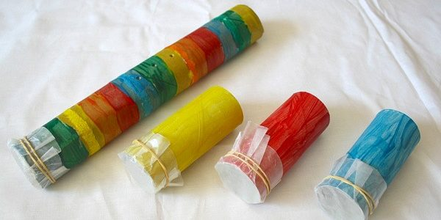 | Dance a sing along with Julia in her ‘Sharing a shell song’  https://www.youtube.com/watch?v=YxbYzI4_DDg | Handwriting
W | Miss Parker’s Phonics lesson 2 |  | Story Time and milk | Play the maths game you made from Monday. | Halves and quarters video animation.  https://www.youtube.com/watch?v=VMWa6dDoicc |  |  | Writing:  What is Hamish thinking?  Write what you think Hamish is thinking?. Don’t forget to use your best sound talk to spell the words you need. |  | Handwriting
Th | As Tuesday …continue |  | Story and milk | Science and Engineering.  Refer back to your story ‘ Mrs Armitage on Wheels’ .  Either using your bike or your scooter design something from your recycling box at home for your bike or scooter. A basket to carry teddy, a rocket booster to make you go fast, an umbrella to protect you when it rains?  Send us your designs or photos. |  |  |  | Get your grown-ups to help you to make a list of things you have at home to make your picnic for Friday’s food tech time. Make sure there are some healthy choices. Do you know which ones they are. Here’s a song to remind you.  https://www.youtube.com/watch?v=cZ60zhvMlGk |  | Handwriting
F | Miss Parker’s phonics lesson 3 |  | Its Food Tech time!.  Make a picnic just like Mr Grinlings . Use you knowledge of halves to cut things in half or into quarters, not forgetting to make the parts equal.  Try to make it healthy by balancing out key food groups.. Enjoy in your role play light house or in your garden. Watch out for the seagulls! |  |  |  |  | Think about our core values and learn our Southridge songs with your grown-ups.  Plan out next to each core value what you could do this weekend to achieve them. If you achieve your goals and your grown-ups may give you a special treat?  Its Fishy Friday!!!!!!!!!!!

