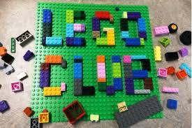

**Role Play.** This week we have seen the arrival of exciting new resources for our role play and small world areas and the children can’t wait to get started unpacking them. Role play/pretend play is an important part of child development, as it builds confidence, creativity, communication skills, physical development and problem solving. Along with being lots of fun, it allows children to get into character and act out real life roles and fictional performances. It encourages empathy between children and allows them to act out real life situations, practise what they have already learnt and get creative!

We would love to hear about your child’s engagement in this area of play at home and it will be super evidence for learning journals.

**Clubs.** Clubs started this week with Lego Club on Wednesday and Cooking Club on Thursday. Lego Club is a fun way to boost those important fine motor skills needed for cutting, drawing and writing. It teaches children to think in three dimensions whilst developing problem solving, organisation and planning skills. Communication and critical thinking is enhanced and literacy is improved when working with instructions.

In Cooking Club the children prepare and sample their own fun, healthy snacks whilst learning about where our food comes from and (sensitively) discussing the importance of a healthy balance in our diet.

You might like to check out the Change4life website ([www.nhs.uk/change4life/food-facts](http://www.nhs.uk/change4life/food-facts)) which is a good resource packed with information for parents and lots of fun activities to share with your children.

We would love to hear your child’s reaction/feedback from clubs they have attended. Send us their quotes.

[Helen.mason@ntlp.org.uk](mailto:Helen.mason@ntlp.org.uk) Tanya.parker@ntlp.org.uk

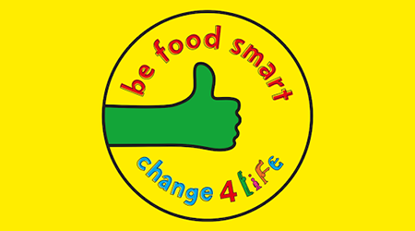



Southridge First School Reception Newsletter 18.1.19