**Lunch Times.**

Lunch times have been extremely successful again this week, all children have had a positive experience. Some families have prepared their child by discussing the menu in the morning before school and this has been a tremendous help. Menus can be seen on the North Tyneside Council website or Google search North Tyneside school menu. **(Please prepare your child to make a ‘second choice’. Occasionally the menu has to be adapted if deliveries are late etc.)**

**Panto and Party Day!**

We are planning to take a trip to the pantomime at Whitley Bay Play House in the morning of the 10th December. This will be part of our Christmas party day. We will be relying on parent help on the day, we need at least 10 adults per class. If you are available and would like to join us at the panto please let a member of staff know as soon as possible.

[Tanya.parker@ntlp.org.uk](mailto:Tanya.parker@ntlp.org.uk) [Helen.mason@ntlp.org.uk](mailto:Helen.mason@ntlp.org.uk)

**Parent Workshop.**

We are very much looking forward to seeing Reception parents on Monday evening (17th September) for our ‘Parent Workshop’ which will run from 5 – 6pm in the school hall. The aim of the workshop is to give you all tips, advice and reassurance on how to support your child through the Reception year.



Have a lovely weekend everyone.

We have had some leaking water bottles this week so please do not put water bottles inside book bags. Many thanks.



**Thank you** for the named wellies. They are waiting patiently in the cloakroom for the puddles to arrive!



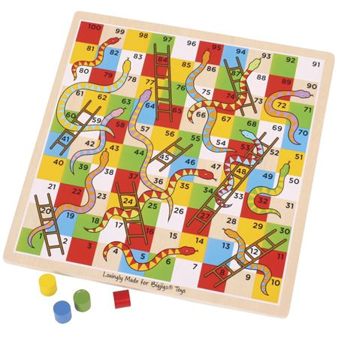



**Reception Newsletter: 14.9.18**

