There are opportunities here to discuss why some writing is in capital letters.

Does your child know any capital letters?

What is the mark at the end of SPLASH ?

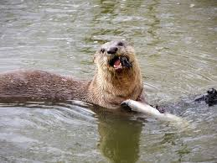

The moon was bright.

The otter was in a fun mood.

She jumped in her pool at the zoo.

SPLASH!

It got the zoo man wet too.

***Before you start? Do you know the speed sounds and tricky words. I need to read this with confidence.***

**Learn these red words before reading. (You may want to cut them up to play games with and practise).**

The was her

**Speed digraph sounds to revise** :

ch sh th ng nk ay ee igh ow oo