 | Mathematics | Language & Literature | Health, Fitness & Wellbeing | Science and Nature | Challenge of the Day  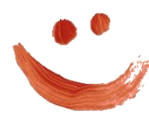
 | Monday Maths Project (a creative idea to last all week!)  (adaptable for all ages)  Zoo Creator  CLICK HERE | Story of the Day  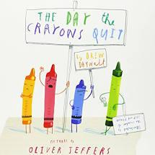  ‘The day the Crayons Quit’ by Drew Draywolt and Oliver Jeffers KS1  CLICK HERE | Moments for the Mind: Chalks Away!  Chalk an obstacle course  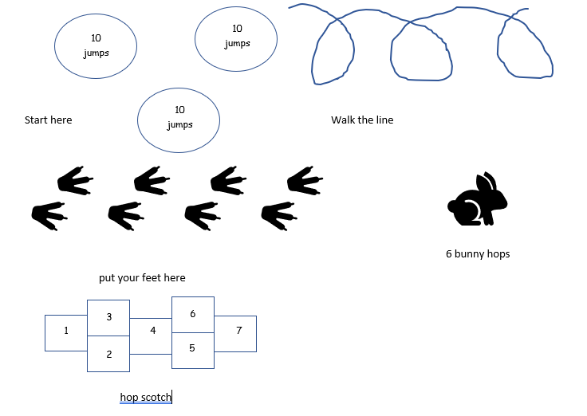  click here  Fit and Fabulous  Have a go at your completed Chalks Away! | Cardboard Challenge  Try this excellent STEM Challenge from Science Sparks  What will you make?  CLICK HERE  Share your models using the #ntedugames2020 hashtag | Let’s go Lego!  Have a go at our lego challenges  click here
 | Maths Puzzle:  Can you solve it ?  Move just three sticks to make 2 squares.  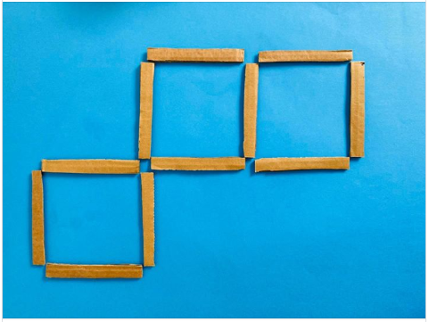  (Click HERE) | Story of the Day  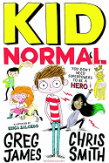  ‘Kid Normal’ by Greg James and Chris Smith UKS2 Murph Cooper’s mum has enrolled him at a school for superheroes by mistake.  CLICK HERE | Moments for the Mind: Beauty  The beauty of the world  click here  Fit and Fabulous  Have a go at the PE Teams’ Daily Challenge on Twitter? | Design an Antarctic Holiday!  Use the “Tourism” section of the brilliant Discovering Antarctica website to put together a plan for a 3-day holiday in Antarctica.  What sort of activities might you do?  What do you need to be careful of? | Would you rather?  Find out random facts about your friends and family  click here
 | Time for a NEW Maths Game..  Square Game  Make squares to win points. Easy at first. But soon you’ll be looking for some very well hidden squares.. (age 7+)  CLICK HERE  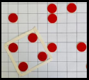 | Story of the Day  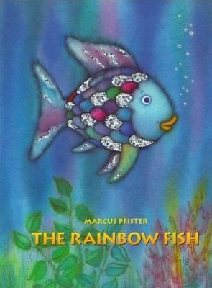  ‘The Rainbow Fish’ by Marcus Pfist  KS1  CLICK HERE | Moments for the Mind: Mountain High  Yoga to soothe the soul and body  click here  Fit and Fabulous:  Time for a Tik Tok  Show us your best dance moves! | Chain Reactions  Can you make your own simple Rube Goldberg Machine? You could try an easy indoor one or a more adventurous outdoor version.  The trickiest example involves a fan and balloon  CLICK HERE | Tongue Twister Challenge!  How fast can you say these tongue twisters? Challenge your friends and family!  Click here
 | Close to 100 - Digit Card Game:  (ages 7+)  A great game for Place Value and practising written and mental calculation skills.  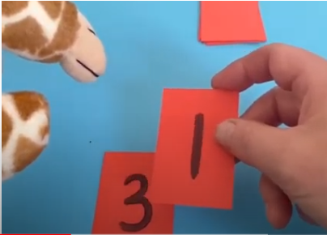  Click HERE | A Poem a Day  Peaches, Plums and all things Gruesome  Explore today’s handpicked poems for EYFS, KS1 and KS2 and try out some of the activities included.  Click here | Moments for the Mind: Alto’s Adventure  Follow Alto and chill.  click here  Fit and Fabulous  Be inspired by Captain Tom Moore - how many laps of your garden/yard/street can you walk in 20 minutes?  Don’t forget to clap for key workers tonight at 8pm. | Making Cartesian Divers  Have a go at making an awesome cartesian diver from some simple materials.  CLICK HERE | King or Queen for the day.  Ladies and gentlemen, you are cordially invited to Buckingham Palace.  enter here  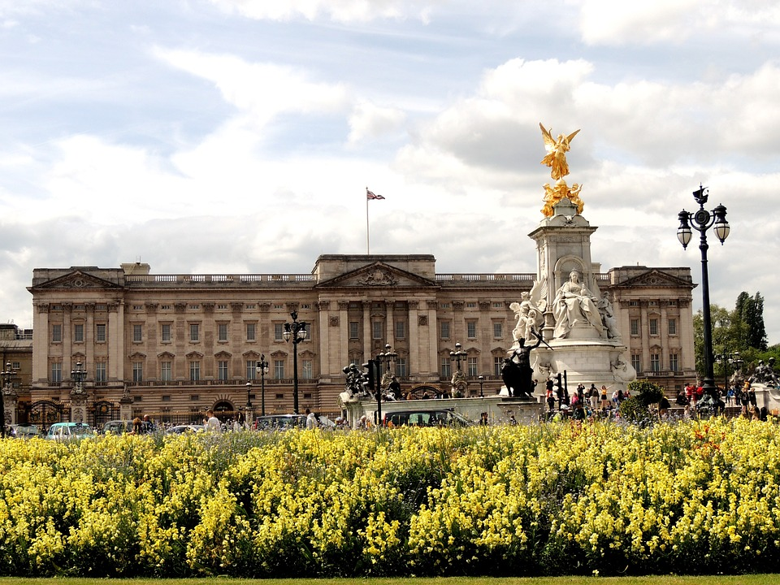
 | The 6,5,4 Game  A great game for all ages!  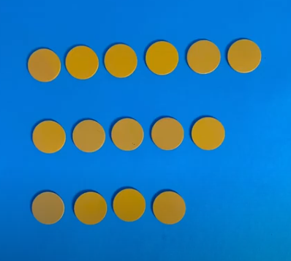  Click HERE | Story of the Day  ‘Once Upon an Alphabet’ by Oliver Jeffers  A collection of short stories.  LKS2  CLICK HERE | Moments for the Mind and Fit and Fabulous combined  Funtime Friday  Put on your favourite tunes, pump up the volume then sing and dance like no-one is watching | The Moon Camp Challenge!  The moon camp challenge is an educational programme that challenges students to design their own Moon settlement  The deadline has been extended until 7th May. CLICK HERE. | Kings and Queens  Watch this video and see how many of our British Kings and Queens you can remember in order.  Click here  