Yum!

I can get chips.

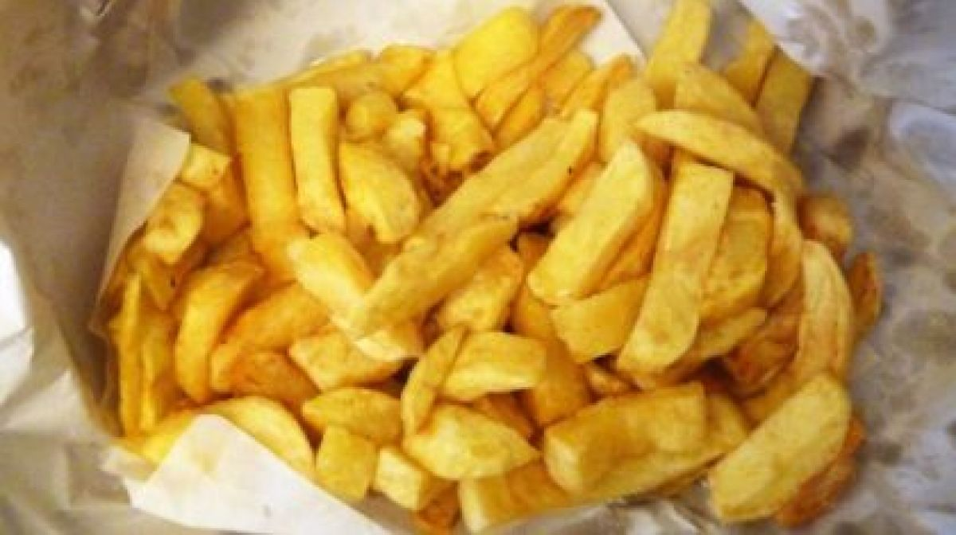

**I** can get a fish.



I can get the shop.



***Before you start? Do you know the speed sounds and tricky words? I need to read this with confidence.***

**Learn these red words before reading. (You may want to cut them up to play games with and practise).**

**I the**

**Speed digraph sounds to revise** :

**sh ch th qu ng nk**