Symmetrical Patterns
Using the example as a guide, colour in the grids to make symmetrical patterns. Some patterns you can design yourself and others have been provided for you. Look carefully for the mirror line on each grid.
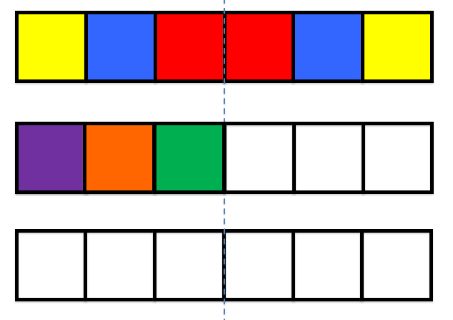

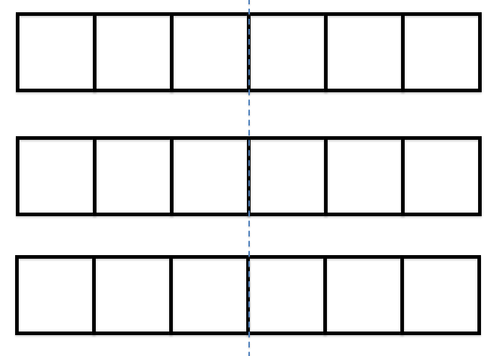
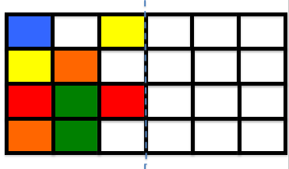
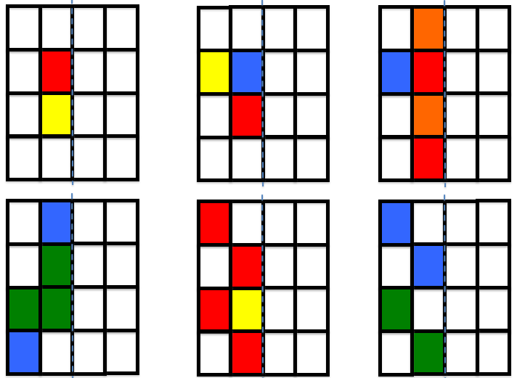
Tricky Challenge Time!
Look up some flags online or using an atlas and see if you can find any that are symmetrical. Can you design your own symmetrical flag?

