**URGENT REQUEST!**

**Pebbles for our Pebble Pit.**

**Please could you begin to collect pebbles for our outdoor area - big ones would be ideal.**



One of the children in Reception had a wonderful idea. (Children always have the best ideas). They asked if we could paint a stone and leave it for someone to find.

**We thought we could plan a walk, with your help of course, so if you are free on Friday 11th October from 9.30-11.00 please email your class teacher.**

[tanya.parker@ntlp.org.uk](mailto:tanya.parker@ntlp.org.uk) / joanne.flitcroft@ntlp.org .uk

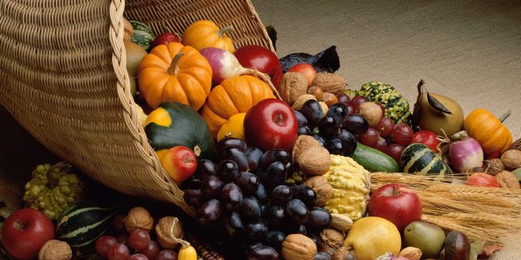

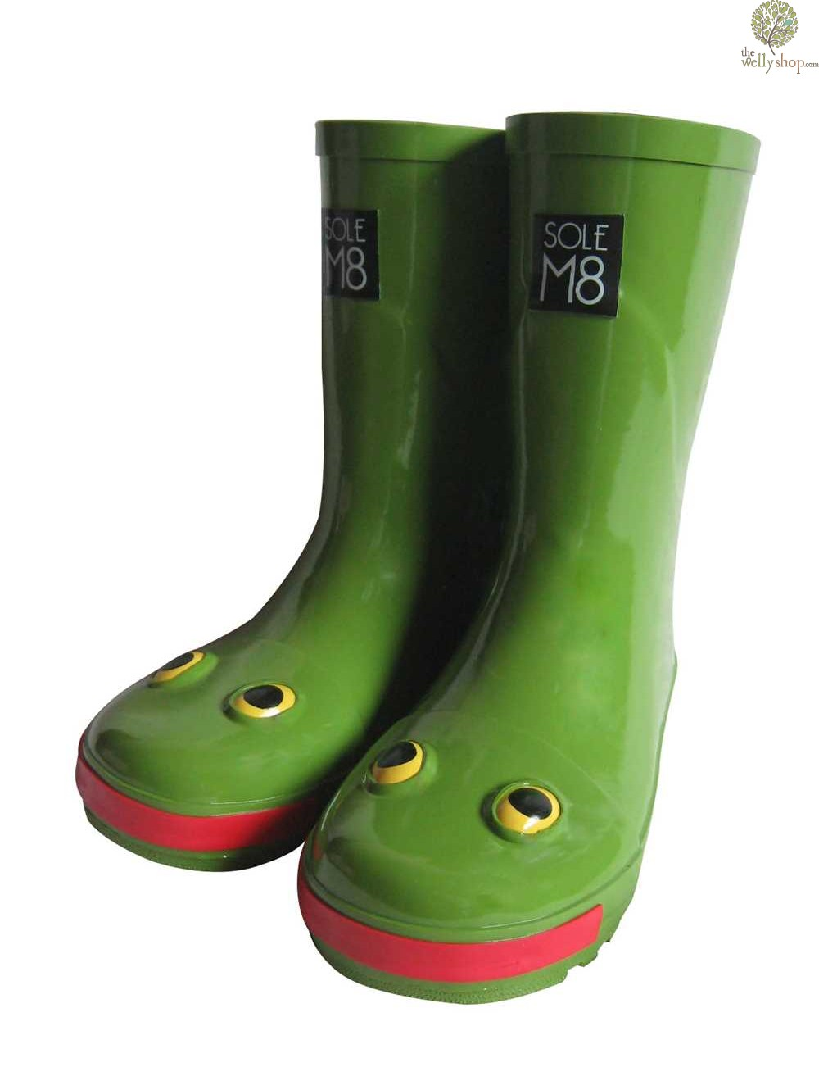

Please bring in a named pair of wellies to leave in school. We have purchased some new all in one waterproofs for access to outdoors and we need a comfortable pair of wellies to tuck them into. We will leave these under your child’s peg.

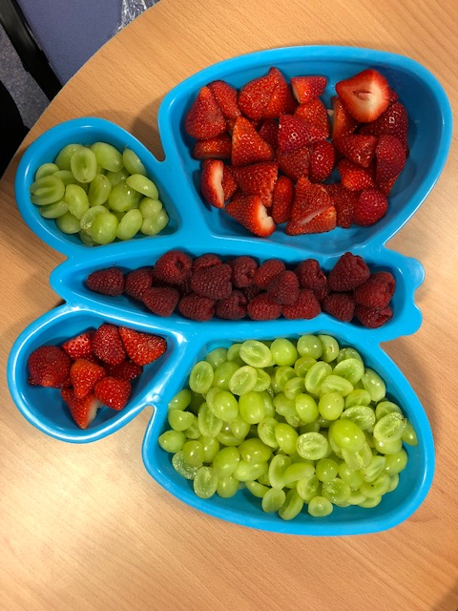

This week in mathematics we have been counting forwards and backwards and enjoying number songs.

In phonics we have been learning phonemes and how to blend them.

We have been learning our core values school song and thinking about what it means.

Children will have a chance to perform this and another two songs at the Harvest Festival on Wednesday 25th September. 9.10

We have a number of birthdays approaching across Reception classes.

Children can come to school in their own clothes the day of their birthday. We are happy to hand out party invitations to the whole class but only the whole class. If you wish to select individual children in small numbers please do so independently of school. This is to protect the feelings of the youngest of our children.

We have just received our Heathy Schools award for this year. Part of the criteria means we cannot hand out cake or sweets when it is a birthday as we are a healthy school. However we find lots of other ways to celebrate and sometimes parents send in a fruit platter on birthdays to share with the class.



We have had another lovely week this week. Everyone has been super. We have enjoyed getting to know your child and we can’t believe that it is still only week 2. Lunchtimes have been a breeze with confident children approaching the hatch and very good eaters. Well done to all those who have pre warned children of the menu as they are very sure about what to pick. Most children eat the vast majority of their food which is also a good sign.

All Reception staff have been fabulous when supporting our children from helping with knife and fork skills, selecting salad or vegetables to accompany their main course, carrying trays and clearing away their dishes and cutlery. This care and attention has been well invested which shows in the happiness of the children.

**Reception Newsletter: 12.9.17**