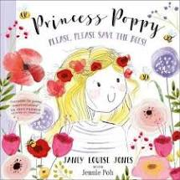

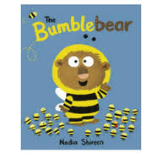

Story time. Listen to Mrs Mason read The Bumblebear written by Nadia Shireen

Yoga How about trying some yoga with Enzo the Bee at Cosmic Kids Yoga

<https://www.youtube.com/watch?v=uyj5LooYWyg>

Story time. Listen to Mrs Scott read Princess Poppy: Please, please save the bees.

Which sound can you hear at the beginning of bumble and bee? Can you think of any other words that begin with b?

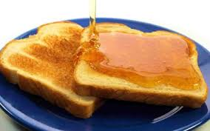

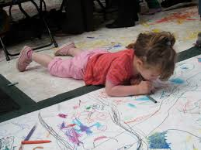

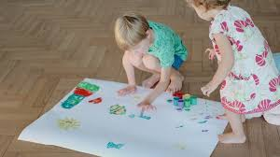

Bee Counting. Use your fingers to join in bee counting with Mrs Mason.

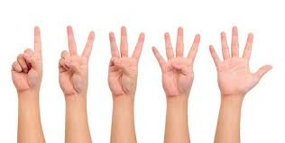

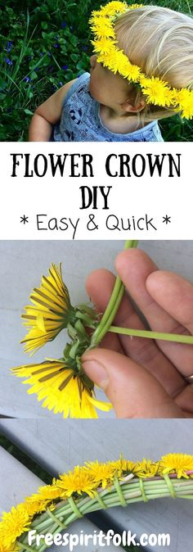

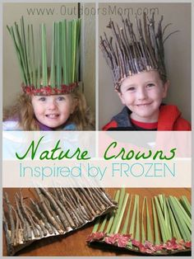

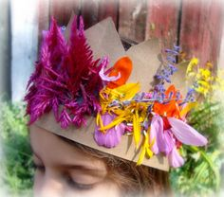

Create. I wonder if you could make a beautiful natural crown and pretend to be the queen bee protecting the honey store.

Adults can watch the clip on how to make a crown if they need inspiration. <https://www.youtube.com/watch?v=Y_AofUPNwmk>

Watch the Flight of the Bumble Bee <https://www.youtube.com/watch?v=X14kC-sEH0I> Then play the music and roll out big rolls of paper. Use pencils or crayons to free draw to the music. Just like we do for Wiggle and Squiggle. Let your crayon represent the bee on his journey as he wiggles and waggles between the flowers and his hive. Flight of the Bumble Bee music <https://www.youtube.com/watch?v=LI3wIHFQkAk>

Home Learning Ideas.

Week Beginning 8th June

Do you like honey? Ask your grownup if you can taste some honey. Maybe you could make a honey sandwich or spread some on your toast.

Make and Imagine. Turn yourself into a bee, make a bee mask or headband so you can join the bee family.

Which bee would you be?

What would be your special job?

Watch the video about bees and explain how the bees tell each other where the good flowers are by doing a waggle dance.

<https://www.youtube.com/watch?v=B2jfMHWYTDk>

Can you do the waggle dance like a worker bee?