**Sun Cream**.

Please ensure that children have water bottles and named sun hats in school. All day sun screen protection should be applied before the children arrive at school.





**Last day Pirate Day!**

As mentioned in a previous newsletter Thursday 23rd May is the last day of this half term and we are having a pirate themed day. Children can come to school dressed in pirate themed clothes/costumes and bring a donation of £1. Donations collected will help the Friends of Southridge and support STEM week which will take place in school in June.

**Woodhorn Colliery Museum Tuesday 21st May.**

On Tuesday morning the doors to Reception will be open so children can come straight in without lining up on the yard as we aim to leave promptly following register. Children should wear **school uniform** and **sensible shoes**, a **sun cap** and a **rain coat**. **Please can all children have sun cream applied at home before school.** The children will be provided with a packed lunch from school which will include water but they will need to **bring their water bottles** to keep them hydrated throughout the day. We aim to be back in school before the end of the school day so pick up is usual time.

**Many thanks to our parent volunteers.**

Parent volunteers should meet at school to car share and follow behind the coach. Parents will need to bring their own packed lunch and drinks as the cafe will be closed. Can we please ask that parents do not bring sweets.

**Walk to School Week.**

Its national walk to school next week and thousands of schools around the country will be taking part in the initiative to get everyone active whilst cutting down on congestion and pollution. It would be great if as many of our children as possible could get involved and walk, cycle or scoot to school.



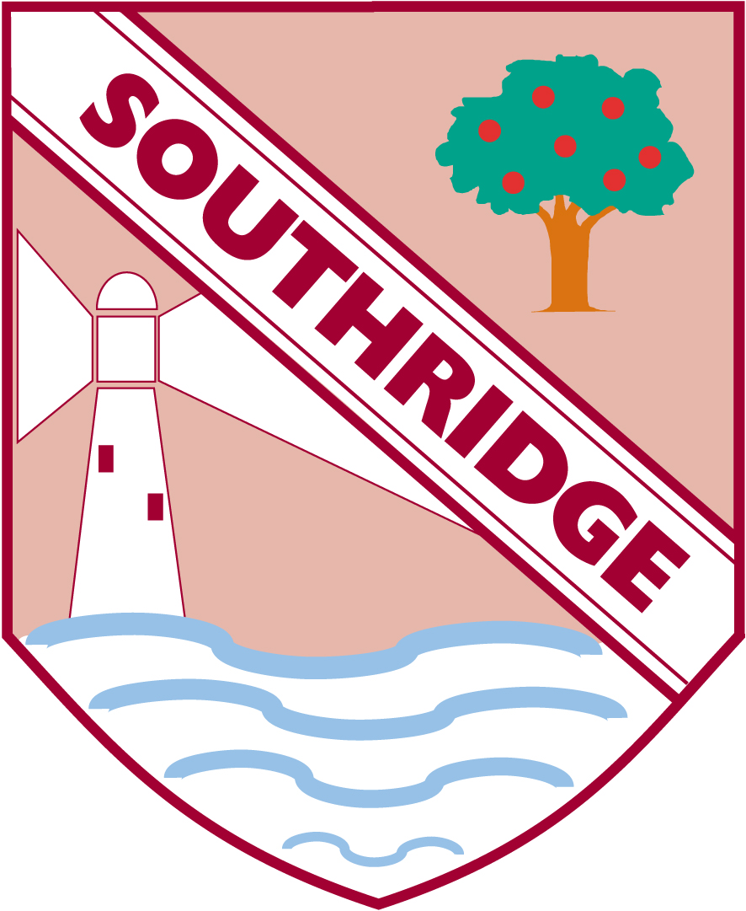

Southridge First School

Reception Newsletter 17.5.19