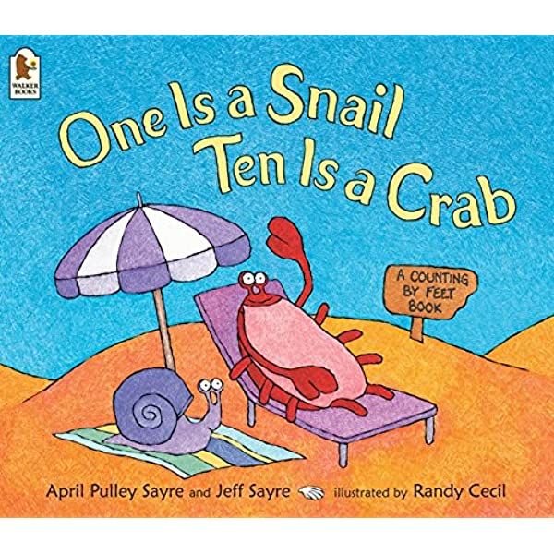

One is a Snail Ten is a Crab.

Listen to Mrs Waller reading One is a Snail Ten is a Crab by April Pulley Sayre and Jeff Sayre.

Somebody Swallowed Stanley!

Listen to the story of Somebody Swallowed Stanley by Sarah Roberts.

Make a shell for a Hermit Crab.

Can you find some junk modelling materials to make a good home for a Hermit crab? What would make a good home for a Hermit crab? Would something soft and squishy do?

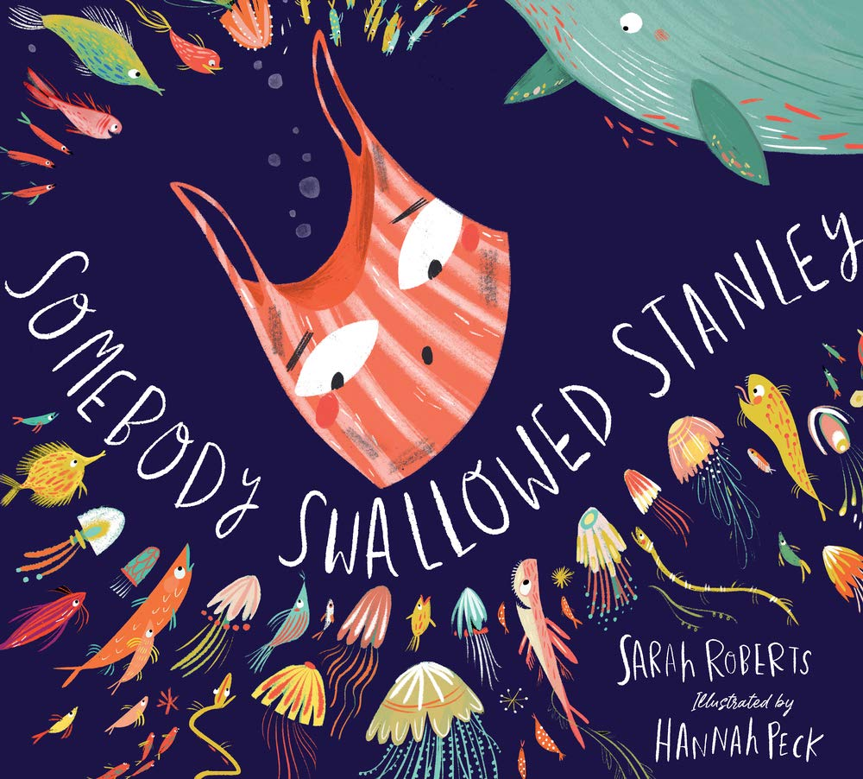

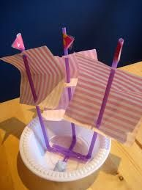

Build a Boat Challenge.

Can you build a boat that can float? Which junk items would be good for a boat? Try experimenting with different materials and discuss with your adult which ones would be most suitable.

Pencil Control Path.

Use your birdie beak pencil grip and draw a line along the path. See if you can try to draw the line right in the middle of the path.

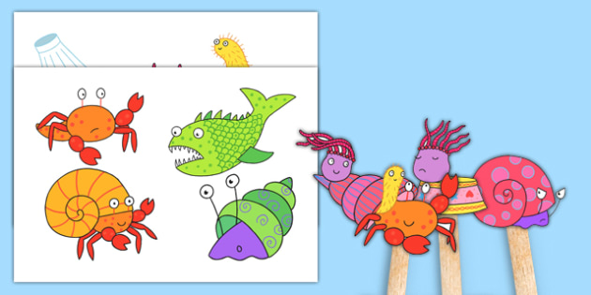

Sharing a Shell Stick Puppets.

Cut out the characters and stick them onto sticks or straws to make puppets then use them to re-tell the story.

Under the Sea Counting.

How many turtles can you see? How many fish can you see? Try writing the number in the circle next to them.



I Spy.

Use your good looking eyes and super searching in the ‘Summer I Spy’ and the ‘Under the Sea I Spy’ attached games. Maybe you could write the number for how many of each item you find? If you need help from an adult that is fine.

Colouring.

Try some colouring. Think carefully about which colours you choose. Don’t forget to use your birdie beak grip.

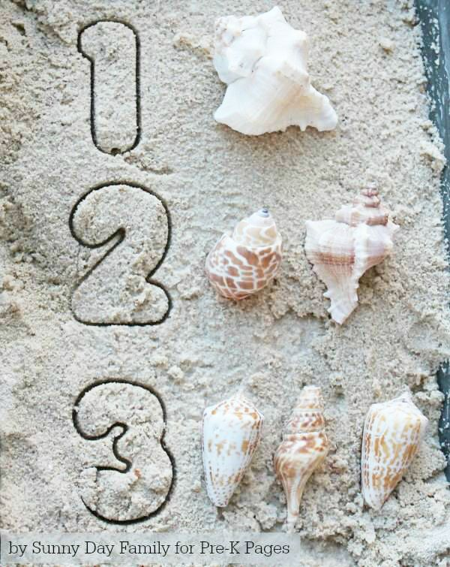

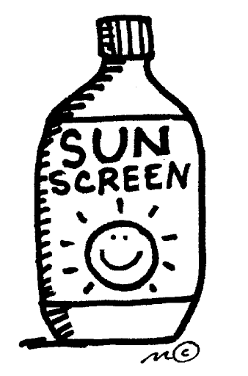

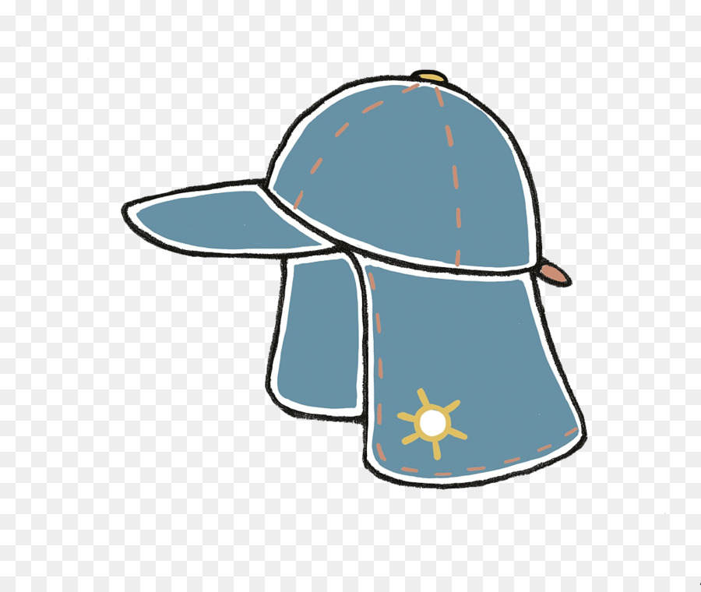

Winter and Summer Sorting.

What kind of clothes do we need in winter? What kind of clothes do we need in summer? Talk to your adult about how we can stay safe when the sun is out. What do we need to do to protect our skin? Cut out the clothes and see if you can sort them into the best clothes for summer and the best clothes for winter?

Home Learning Ideas

Week beginning:

29th June 2020

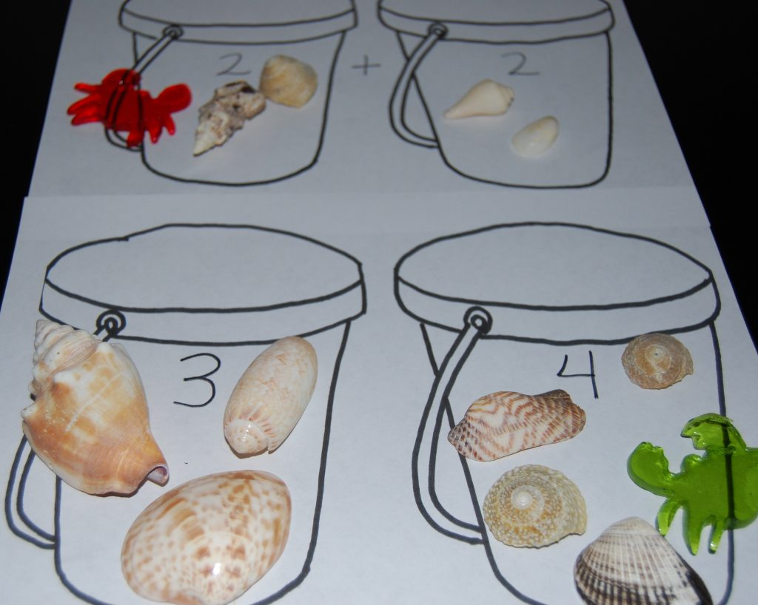

Counting shells.

On your next trip to the beach see how many shells you can find? How about sorting them into groups of different types of shells? You could sort them into groups of 5 or 10. Paint or write numbers on the shells then mix them all up and see if you can put them in order.

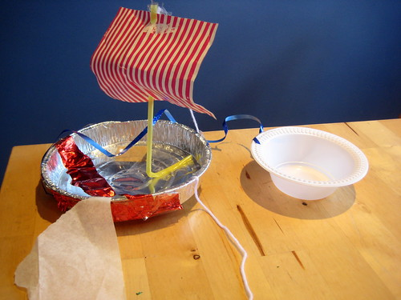

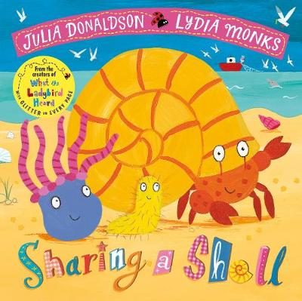

Sharing a Shell.

Listen to the story of Sharing a Shell by Julia Donaldson.