Maggie Maths question
Children often enjoy spotting patterns and making patterns with lots of different things. Maggie would like the children to find as many different ways they can colour a row of three fish using only 3 colours. You can’t use the same colour twice in each row.
For example:
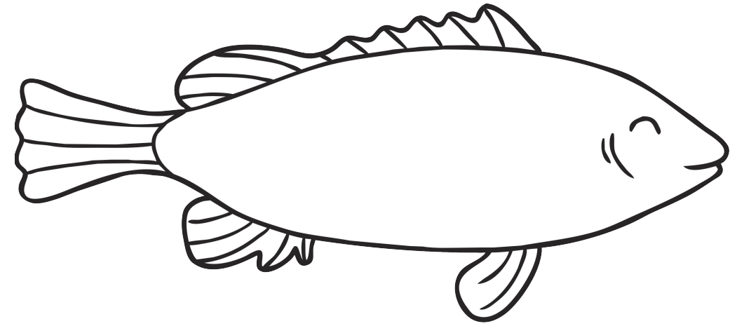

How many different ways are there of colouring the fish?

Challenge: The children may wish to try a row of four fish and 4 different colours.

(HINT: There are 6 different combinations using 3 colours).

