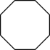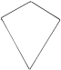

All sides are equal

No right angles

3 sides

# **Sorting**

# **2D Shapes**

4 sides

## Word Bank

### triangle octagon

quadrilateral circle

pentagon oval

hexagon square

rectangle kite

rhombus trapezoid

6 sides

1 curved side

8 sides

5 vertices