
Welcome to the first of your weekly Nursery Newsletters. The aim of the newsletter is:

- To keep you up to date with events in the school calendar.
- To pass on any top tips and advice that you as parents may find useful.
- To inform you of the learning opportunities and experiences that have taken place during the week which you may wish to share or extend with your child at home.

This week in Nursery we have sung some familiar rhymes. Rhyming is important because it helps children develop their listening skills, recognise patterns in words and build early language and literacy skills. Singing rhymes also supports memory, confidence and communication, while providing lots of fun opportunities to learn together.

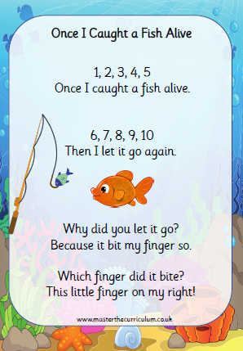

In mathematical Development we have sorted colours at tidy up times and we have been using colours by their name perhaps at home you could play eye spy using the colours – e.g. ‘I spy with my little eye, something coloured red’. This can be played indoors and outdoors/ in the supermarket/ in the car etc.

.

Nursery Newsletter: 11.9.26


We have been learning 1,2,3,4,5 once I caught a fish alive as part of counting and number so perhaps one to try at home

In Mathematical Development we have been learning to describe objects by their colour. Yellow has been a tricky word to pronounce so we have practised this one a lot.

At home try playing I spy when you are out and about at the supermarket, in the car or on a walk with colours as the clue. “I spy with my little eye something that is red”. Try this with red, yellow and blue as these have been our focus colours this week.

Hide a toy that is red, yellow or blue and see if your child can find it? For challenge questions try dark or light red etc


We have made huge progress in such a short time when getting our wetsuit and wellies on independently and using the toilet and remembering to wash our hands.
Please continue to do this at home.

We are very proud of them all.

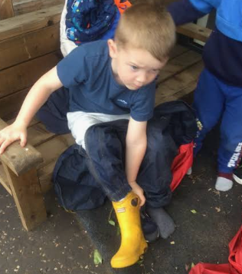
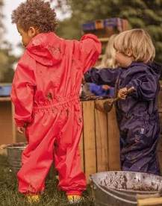

Important Diary Dates and Information

Beach Clean – Tuesday 15th September 3.30 pm
Beach Clean Invitation As everyone knows, we really value making a Positive Impact here at Southridge and to this end, we would like to invite you to join us down on the sea front, next to the Rendezvous Cafe at 3.45pm on Tuesday 15 September. We have litter pickers and bags, but feel free to bring your own - along with enthusiasm and a smile

Have a Nice Weekend
Take care,
The Nursery Team



