Personal, Social Emotional Health and Relationships Education  Curriculum Plans and Mapping  Updated 2022 | 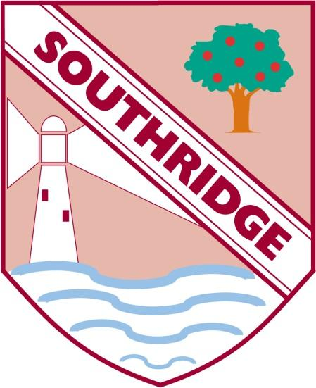

SOUTHRIDGE FIRST SCHOOL – PSEHR . Long Term Plan

Purpose of study

The focus in primary school should be on teaching the fundamental building blocks and characteristics of positive relationships, with reference to friendships, family relationships, and relationships with other children and with adults.

This starts with pupils being taught about what a relationship is, what friendship is, what family means and who the people are who can support them. From the beginning of primary school, building on early education, pupils should be taught how to take turns, how to treat each other with kindness, consideration and respect, the importance of honesty and truthfulness, permission seeking and giving, and the concept of personal privacy. Establishing personal space and boundaries, showing respect and understanding the differences between appropriate and inappropriate or unsafe physical, and other, contact – these are the forerunners of teaching about consent, which takes place at secondary.

Respect for others should be taught in an age-appropriate way, in terms of understanding one’s own and others’ boundaries in play, in negotiations about space, toys, books, resources and so on.

From the beginning, teachers should talk explicitly about the features of healthy friendships, family relationships and other relationships which young children are likely to encounter. Drawing attention to these in a range of contexts should enable pupils to form a strong early understanding of the features of relationships that are likely to lead to happiness and security. This will also help them to recognise any less positive relationships when they encounter them.

The principles of positive relationships also apply online especially as, by the end of primary school, many children will already be using the internet. When teaching relationships content, teachers should address online safety and appropriate behaviour in a way that is relevant to pupils’ lives. Teachers should include content on how information and data is shared and used in all contexts, including online; for example, sharing pictures, understanding that many websites are businesses and how sites may use information provided by users in ways they might not expect.

Teaching about families requires sensitive and well-judged teaching based on knowledge of pupils and their circumstances. Families of many forms provide a nurturing environment for children. (Families can include for example, single parent families, LGBT parents, families headed by grandparents, adoptive parents, foster parents/carers amongst other structures.) Care needs to be taken to ensure that there is no stigmatisation of children based on their home circumstances and needs, to reflect sensitively that some children may have a different structure of support around them; e.g. looked after children or young carers.

A growing ability to form strong and positive relationships with others depends on the deliberate cultivation of character traits and positive personal attributes, (sometimes referred to as ‘virtues’) in the individual. In a school wide context which encourages the development and practice of resilience and other attributes, this includes character traits such as helping pupils to believe they can achieve, persevere with tasks, work towards long-term rewards and continue despite setbacks. Alongside understanding the importance of self-respect and self-worth, pupils should develop personal attributes including honesty, integrity, courage, humility, kindness, generosity, trustworthiness and a sense of justice. This can be achieved in a variety of ways including by providing planned opportunities for young people to undertake social action, active citizenship and voluntary service to others locally or more widely.

Relationships Education also creates an opportunity to enable pupils to be taught about positive emotional and mental wellbeing, including how friendships can support mental wellbeing.

Through Relationships Education (and RSE), schools should teach pupils the knowledge they need to recognise and to report abuse, including emotional, physical and sexual abuse. In primary schools, this can be delivered by focusing on boundaries and privacy, ensuring young people understand that they have rights over their own bodies. This should also include understanding boundaries in friendships with peers and also in families and with others, in all contexts, including online. Pupils should know how to report concerns and seek advice when they suspect or know that something is wrong. At all stages it will be important to balance teaching children about making sensible decisions to stay safe (including online) whilst being clear it is never the fault of a child who is abused and why victim blaming is always wrong. These subjects complement Health Education and as part of a comprehensive programme and whole school approach, this knowledge can support safeguarding of children.

By the end of Primary School pupils should:

Families and people who care for me:

Pupils should know
• that families are important for children growing up because they can give love, security and stability.
• the characteristics of healthy family life, commitment to each other, including in times of difficulty, protection and care for children and other family members, the importance of spending time together and sharing each other’s lives.
• that others’ families, either in school or in the wider world, sometimes look different from their family, but that they should respect those differences and know that other children’s families are also characterised by love and care.
• that stable, caring relationships, which may be of different types, are at the heart of happy families, and are important for children’s security as they grow up.
• that marriage13 represents a formal and legally recognised commitment of two people to each other which is intended to be lifelong.
• how to recognise if family relationships are making them feel unhappy or unsafe, and how to seek help or advice from others if needed.
Caring friendships

Pupils should know
• how important friendships are in making us feel happy and secure, and how people choose and make friends.
• the characteristics of friendships, including mutual respect, truthfulness, trustworthiness, loyalty, kindness, generosity, trust, sharing interests and experiences and support with problems and difficulties.
• that healthy friendships are positive and welcoming towards others, and do not make others feel lonely or excluded.
• that most friendships have ups and downs, and that these can often be worked through so that the friendship is repaired or even strengthened, and that resorting to violence is never right.
• how to recognise who to trust and who not to trust, how to judge when a friendship is making them feel unhappy or uncomfortable, managing conflict, how to manage these situations and how to seek help or advice from others, if needed.

Respectful relationships

Pupils should know
• the importance of respecting others, even when they are very different from them (for example, physically, in character, personality or backgrounds), or make different choices or have different preferences or beliefs.
• practical steps they can take in a range of different contexts to improve or support respectful relationships.
• the conventions of courtesy and manners.
• the importance of self-respect and how this links to their own happiness.
• that in school and in wider society they can expect to be treated with respect by others, and that in turn they should show due respect to others, including those in positions of authority.
about different types of bullying (including cyberbullying), the impact of bullying, responsibilities of bystanders (primarily reporting bullying to an adult) and how to get help.
• what a stereotype is, and how stereotypes can be unfair, negative or destructive.
• the importance of permission-seeking and giving in relationships with friends, peers and adults.

Online relationships

Pupils should know
• that people sometimes behave differently online, including by pretending to be someone they are not.
• that the same principles apply to online relationships as to face-to-face relationships, including the importance of respect for others online including when we are anonymous.
• the rules and principles for keeping safe online, how to recognise risks, harmful content and contact, and how to report them.
• how to critically consider their online friendships and sources of information including awareness of the risks associated with people they have never met.
• how information and data is shared and used online.

Being safe

Pupils should know
• what sorts of boundaries are appropriate in friendships with peers and others (including in a digital context).
• about the concept of privacy and the implications of it for both children and adults; including that it is not always right to keep secrets if they relate to being safe.
• that each person’s body belongs to them, and the differences between appropriate and inappropriate or unsafe physical, and other, contact.
• how to respond safely and appropriately to adults they may encounter (in all contexts, including online) whom they do not know.
• how to recognise and report feelings of being unsafe or feeling bad about any adult.
• how to ask for advice or help for themselves or others, and to keep trying until they are heard.
• how to report concerns or abuse, and the vocabulary and confidence needed to do so.
• where to get advice e.g. family, school and/or other sources.

Nursery
Autumn 1 | Being Me in My World  - I understand how it feels to belong and that there are lots of different and similar  - I can start to recognise my feelings.  - I know that working with others makes school a good place.  - I know why it is good to have gentle hands.  I know that all my friends are allowed to play.  - I am learning what being responsible means. | Curriculum intent  - Friendship  - Kindness  - Respect  - Responsibility  - Honesty | Possible Links  UTW  EAD
Autumn 2 | Celebrating Difference  - I know what it feels like to be proud of something I am good at.  - I can tell you one way that I have been special and unique,  - I know that all families are different.  - I know there are lots of different houses and homes.  - I can tell you ways to make new friends.  - I know how to use words to stand up for myself. | - Friendship  - Kindness  - Respect  - Responsibility  - Honesty | UTW  EAD
Spring 1 | Dreams and Goals  - I understand what challenge means.  - I can keep trying until I do something.  - I can set a goal and work towards it.  - I know some kind words that I can use with friends.  - I am thinking about jobs I may like to do when I am older.  - I feel proud when I achieve a goal. | - Friendship  - Kindness  - Respect  - Responsibility  - Honesty | PD  UTW
Spring 2 | Healthy Me  - I understand I need to be active to be healthy and I know some parts of the body.  - I can tell you some of the things that lead to a healthy and active lifestyle.  - I know what the word healthy means and that some foods are healthier than others.  - I know how to help myself to go to sleep.  - I can wash my hands and I know it is important to do this after the toilet and before I eat.  - I know to say NO to strangers. | - Friendship  - Kindness  - Respect  - Responsibility  - Honesty | UTW  PD  EAD
Summer 1 | Relationships  - I know about my family.  - I understand how to make friends if I feel lonely.  - I know what I like about my friends.  - I know what to do or say if someone is mean to me.  - I know the class strategies to calm me.  - I know what to do to work and play happily with my friends | - Friendship  - Kindness  - Respect  - Responsibility  - Honesty | UTW
Summer 2 | Changing Me  - I know some parts of the body and can show respect for myself.  - I can tell you some things I do and eat that make me healthy.  - I know we all start form babies and grow into children then adults.  - I know I grow and change.  - I can talk about how I feel moving from Nursery to school.  - I can remember some fun things in Nursery year | - Friendship  - Kindness  - Respect  - Responsibility  - Honesty | UTW

Reception
Autumn 1 | Being Me in My World  - I know how it feels to belong and that we are similar and different.  - I am beginning to recognise and manage my feelings.  - I enjoy working with others to make school a good place.  - I know what it is to have gentle hands and be kind.  - I am beginning to understand children’s rights and that we can all learn and play.  - I am beginning to understand what being responsible means. | Curriculum Intent  - Friendship  - Kindness  - Respect  - Responsibility  - Honesty | Possible Links  UTW  EAD
Autumn 2 | Celebrating Difference  - I know something I am good at.  - I understand that being different makes us all special.  - I know that we are all different but the same in lots of ways.  - I know why my home is special to me.  - I can tell you how to be kind to a friend.  - I know which words to use to stand up for myself when someone is being unkind. | - Friendship  - Kindness  - Respect  - Responsibility  - Honesty | UTW  EAD
Spring 1 | Dreams and Goals  - I know what challenge means and that if I persevere, I can tackle them.  - I can tell you about a time that I didn’t give up.  - I can set a goal and work towards it.  - I can use kinds words to encourage people.  - I understand that if I learn it will hlp me to do the job that I would like to do,  - I can say how I feel when I achieve a goal and know what it means to feel proud. | - Friendship  - Kindness  - Respect  - Responsibility  - Honesty | PD  UTW
Spring 2 | Healthy Me  - I know I need exercise to keep healthy.  - I know how moving, and resting are good for my body.  - I know ways to help myself go to sleep.  - I know how to wash my hands thoroughly and I know why this is important.  - I know what a stranger is and what I should do if one approaches me.  - Know how to keep calm and deal with difficult situations | - Friendship  - Kindness  - Respect  - Responsibility  - Honesty | UTW  PD  EAD
Summer 1 | Relationships  - I know the kinds of jobs I do in my family.  - I know how to make friends to stop myself feeling lonely.  - I can think of ways to solve problems.  - I am starting to understand the impact of unkind words.  - I know some ways to relax and stay calm.  - I know how to be a good friend. | - Friendship  - Kindness  - Respect  - Responsibility  - Honesty | UTW
Summer 2 | Changing Me  - I can name parts of the body.  - I can tell you some things I do and foods that I eat that will keep me healthy.  - I understand that we all grow form babies to adults.  - I can express how I feel about moving to year 1.  - I can talk about my transition worries and things that I am looking forward to.  - I can share memories of the best bits in Reception. | - Friendship  - Kindness  - Respect  - Responsibility  - Honesty | UTW

Year 1
Autumn 1 | Being Me in My World  - /I feel special and safe in my class.  - I understand the rights and responsibilities a member of my class.  - I know how to make my class a safe place for everybody.  - I know my views are valued.  - I recognise the choices I make and know there are consequences.  - I understand my rights and choices within our school rules | Curriculum Intent  - Friendship  - Kindness  - Respect  - Responsibility  - Honesty | Possible Links  Speaking and listening  Art / portraits / landscapes
Autumn 2 | Celebrating Difference  - I can identify similarities between people in my class. .  - I know there are difference between people in our class.  - I know what bullying is.  - I know who to talk to if I am unhappy or being bullied.  - I know how to make new friends and how that feels.  - I know how I am different from my friends. | - Friendship  - Kindness  - Respect  - Responsibility  - Honesty | Geography  Cultural art from around the world / Art critique.  R.E
Spring 1 | Dreams and Goals  - I know how to set simple goals for myself.  - I can set a goal and now if I have done my best.  - I know how to work well with a partner.  - I know that challenge will stretch my learning.  - I know what obstacles are in challenge and can work out how to overcome them.  - I know how it feels to achieve a challenge . | - Friendship  - Kindness  - Respect  - Responsibility  - Honesty | History  P.E
Spring 2 | Healthy Me  - I know the difference between healthy and unhealthy and know some ways to keep healthy.  - I know how to make Healthy lifestyle choices  - I know the ways to keep myself clean and heathy. I know that some household products could hurt me.  - I know medicines help me when I am ill but I must be safe wit them.  - I know ways to keep safe around roads and traffic.  - I know why my body is amazing. | - Friendship  - Kindness  - Respect  - Responsibility  - Honesty | Science  ICT / Online safety / stranger danger/ dentist
Summer 1 | Relationships  - I know there are lots of different kinds of families and who my family members are.  - I know what being a good friend means.  - I know ways that are appropriate to greet my friends.  - I know who can help me in my school community.  - I know what qualities I need as a person and a friend.  - I can tell you why I appreciate someone who is special to me | - Friendship  - Kindness  - Respect  - Responsibility  - Honesty | Geography  R.E
Summer 2 | Changing Me  - I know about human and animal lifecycles.  - I know what things about me that have changed.  - I can tell you how my body has changed since I was a baby.  - I can tell you the arts of the body that make boys and girls different.  - I know that every time I learn something new I change a little bit.  - I can tell you about changes that have happened in my life and talk about my feelings. | - Friendship  - Kindness  - Respect  - Responsibility  - Honesty | Science  History

Year 2
Autumn 1 | Being Me in My World  - I know some of my hopes and fears for this year.  - I know the responsibilities of being a member of my class and school.  - I know the rights and responsibilities of being a member of m y class.  - I know I need to listen toother people and contribute my own ideas about rewards and consequences.  - I know how the core values help others learn.  - I know I need to work cooperatively. | Curriculum Intent  - Friendship  - Kindness  - Respect  - Responsibility  - Honesty | Possible Links  Speaking and listening  Art / portraits / landscapes
Autumn 2 | Celebrating Difference  - I understand some ways in which boys and girls are similar and feel good about this.  - I understand some ways in which boys and girls are different and accept that this is OK  - I can tell you how someone who is bullied feels, I can be kind to children who are bullied.  - I can recognise what is right and wrong and know how to look after myself  - I know some ways to make new friends I can tell you some ways I am different from my friends | - Friendship  - Kindness  - Respect  - Responsibility  - Honesty | Geography  Cultural art from around the world / Art critique.  R.E
Spring 1 | Dreams and Goals  - I can tell you about a person who has faced difficult challenges and gained success.  - I can identify a dream/ ambition that is important to me.  - I enjoy facing new learning challenges and working out the best ways to achieve them.  - I am excited and motivated about working out the best way to do things that are challenging.  - I know I am respocible for my own learning and that I have to face challenges with appositive attitude.  - I recognise obstacles which might hinder my achievement.  - I evaluate my own learning and can think about how it could be better next time. | - Friendship  - Kindness  - Respect  - Responsibility  - Honesty | History  P.E
Spring 2 | Healthy Me  - I know that exercise is healthy and how important my lungs, heart and organs are.  - I know that exercise is healthy and how important my lungs, heart and organs are  - I can reflect on my prior learning about medicines.  - I can identify things, people and places where I need to keep safe.  - I know like medicines; household substances can be harmful to me.  - I understand how complex my body is and how to take care of it. | - Friendship  - Kindness  - Respect  - Responsibility  - Honesty | Science  ICT / Online safety / stranger danger/ dentist
Summer 1 | Relationships  - I can identify the roles of my family and my responsibility within that family.  - I can put into practise the friendship skills I have learnt about, and I know what a good communicator is.  - I know some strategies to keep myself safe.  - I know that some peoples work around the world affect me.  - I understand my needs and rights and how these are shared with children around the world. I know how their lives maybe different.  - I know how to express my appreciation to my friends and family. | - Friendship  - Kindness  - Respect  - Responsibility  - Honesty | Geography  R.E
Summer 2 | Changing Me  - I know the cycles of life in nature.  - I recognise that I cannot control growing old and I know someone who is older than me that I respect.  - I know how my body has changed since I was a baby.  - I know the physical differences between being a boy and a girl.  - I know what kinds of touch I like and don’t like and I know to ask for help if I need it.  - I know what I am looking forward to when I go to year 3. | - Friendship  - Kindness  - Respect  - Responsibility  - Honesty | Science  History

Year 3
Autumn 1 | Being Me in My World  - I recognise my worth and know positive achievements about myself and I can set goals.  - I can face new challenges positively , make responsible choices and ask for help when I need it.  - I understand why rules are important and how they relate to rights and responsibilities.  - I understand my actions affect others and I care about other’s feelings.  - I know how to make responsible choices and take action.  - I know that others have a point of view and try to see it from there perspective. | - Friendship  - Kindness  - Respect  - Responsibility  - Honesty | Possible Links  Speaking and listening  Art / portraits / landscapes
Autumn 2 | Celebrating Difference  - I understand that everyone’s family is different and important to them.  - I understand that differences and conflicts may occur in families.  - I know what it means to be a witness to bullying.  - I know that witnesses can make a situation better or worse by what action they take.  - I know words are used in hurtful ways.  - I can talk about a time when my words hurt someone and reflect on the consequences. | - Friendship  - Kindness  - Respect  - Responsibility  - Honesty | Geography  Cultural art from around the world / Art critique.  R.E
Spring 1 | Dreams and Goals  - I can tell you about someone who has faced difficult challenges and achieved success.  - I can identify a dream/ ambition that is important to me.  - I know to be positive about facing new work challenges and go about the best ways to go about things.  - I know how to be motivated and enthusiastic to face a new challenge.  - I know how obstacles can hinder my achievement, but I know I can take steps to overcome them.  - I know how to evaluate my learning and identify how it can be better next time. | - Friendship  - Kindness  - Respect  - Responsibility  - Honesty | History  P.E
Spring 2 | Healthy Me  - I know my heart and lungs are such important organs and that I need to exercise.  - I know how exercise affects my body and my organs.  - I know and can articulate knowledge of healthy and unhealthy substances.  - I know some important strategies to keep myself safe and who to go to for help.  - I know how to keep myself safe and others at home.  - I understand how complex my body is and how to take care of it. | - Friendship  - Kindness  - Respect  - Responsibility  - Honesty | Science  ICT / Online safety / stranger danger/ dentist
Summer 1 | Relationships  - I know the roles and responsibilities of members of my family.  - I know what good friendship skills are and I put them into practise such as good listener, turn taker.  - I know and can use strategies to keep myself safe.  - I can explain how the work and actions of people in the world influence my life.  - I understand how needs and rights are shared by children around the world and identify how lives can be different.  - I know how to express my feelings and appreciation to my family. | - Friendship  - Kindness  - Respect  - Responsibility  - Honesty | Geography  R.E
Summer 2 | Changing Me  - I know that lots of changes happen in the animal and human world when growing up and know that it is usually the female that will give birth.  - I understand the difference between males and females and people in general.  - I know the name differences between males and females.  - I understand that males and females can do the same task and enjoy the same things I can start to recognise stereotypical ideas I might have about parenting and family roles  - I know what I am looking forward to when I go to year 4. | - Friendship  - Kindness  - Respect  - Responsibility  - Honesty | Science  History

Year 4
Autumn 1 | Being Me in My World  - I know my actions and attitudes affect the class team.  - I know where I fit in the school community and whose role is who.  - I know how democracy works through the school council.  - I know how my actions affect other’s feelings and I can now care and empathise with them.  - I know groups can come together to make decisions.  - I know that having a voice contributes to the school community. | - Friendship  - Kindness  - Respect  - Responsibility  - Honesty | Possible Links  Speaking and listening  Art / portraits / landscapes
Autumn 2 | Celebrating Difference  - I know people sometimes make assumptions about what people look like.  - I understand what influences me to lead to assumptions about how people look.  - I know that bullying can be hard to spot but I also know that I can take action.  - I can tell you why witnesses sometimes join in with bullying and do not tell.  - I know what is special about me and value the ways in which I am unique. | - Friendship  - Kindness  - Respect  - Responsibility  - Honesty | Geography  Cultural art from around the world / Art critique.  R.E
Spring 1 | Dreams and Goals  - I can tell you about some of my hopes and dreams.  - I know that sometimes hopes and dreams do not come true and this can hurt.  - I know that reflect on happy and positive experiences can help me counteract  Disappointment  - . I know how to set a new plan and new goals even if I have been disappointed.  - I know how to take the steps to achieve a goal and can do this successfully as part of a group.  - I know what contributions I have made to the group which has led to success. | - . Friendship  - Kindness  - Respect  - Responsibility  - Honesty | History  P.E
Spring 2 | Healthy Me  - I can recognise how different friendship groups are formed, how I fit into them and the friends I value the most.  - I can recognise the changing dynamics between people in different groups, see who takes on which role e.g the leader.  - I know the facts about smoking and how it affects health.  - I understand fully what keeps me healthy and fit.  - I know when I am being put under pressure and I can resist if I want.  - I know that I have a clear picture in what I believe. | - Friendship  - Kindness  - Respect  - Responsibility  - Honesty | Science  ICT / Online safety / stranger danger/ dentist
Summer 1 | Relationships  - I know that I have a web of relationships of which I am part of, understanding that some are close, and some are distant.  - I know the people I love and how the are special to me.  - I know there are people that I no longer see and can talk about this .  - I know the different points of view in animal rights issues.  - I know how to show love and appreciation for the people and animals around me. | - Friendship  - Kindness  - Respect  - Responsibility  - Honesty | Geography  R.E
Summer 2 | Changing Me  - I know that some of my personal characteristics have come from my birth parents.  - I can describe the main stages of growing  - Talk about people who are special to them and why. Discuss who they can trust and why?  - I know how the circle of change works and apply that to my own life.  - I know that there are changes that I must learn to accept such as moving to middle school.  - I know that middle school will be different but I can think of things that I am going to look forward to and understand I can take all I have learnt there too. | - Friendship  - Kindness  - Respect  - Responsibility  - Honesty | Science  History

Mapping Health and Relationship Education into our Long Term Plans Keystage 1

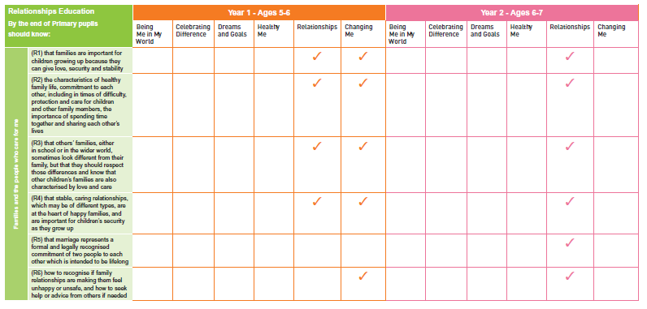

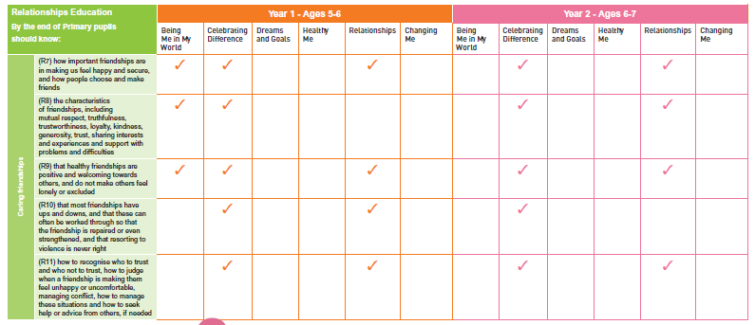

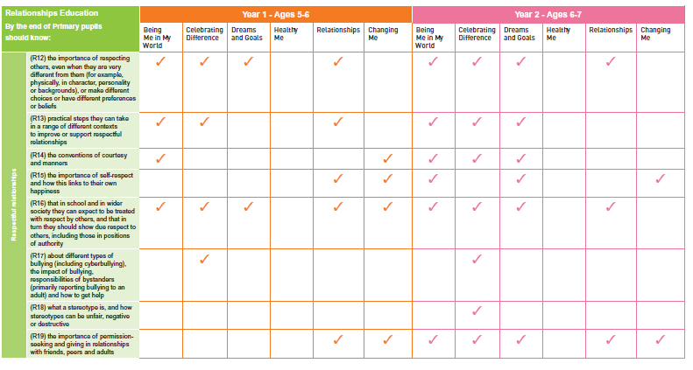

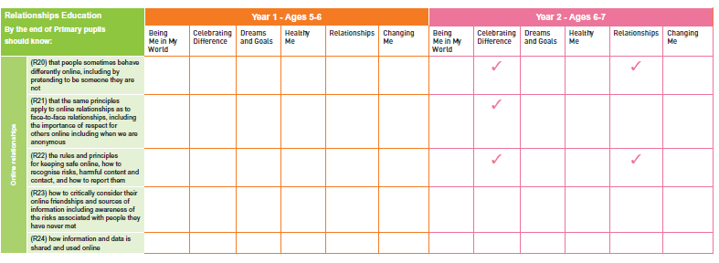

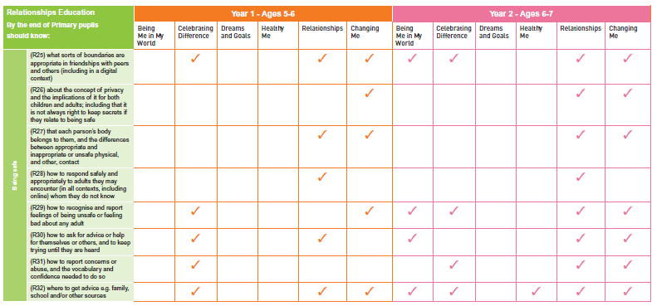

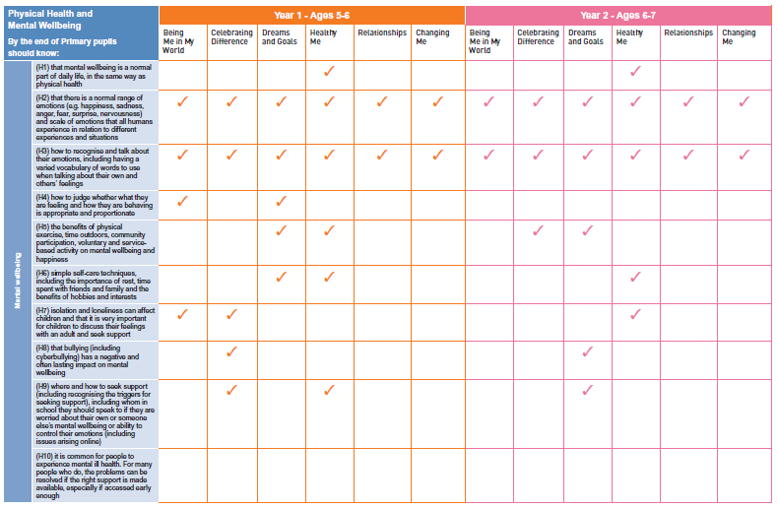

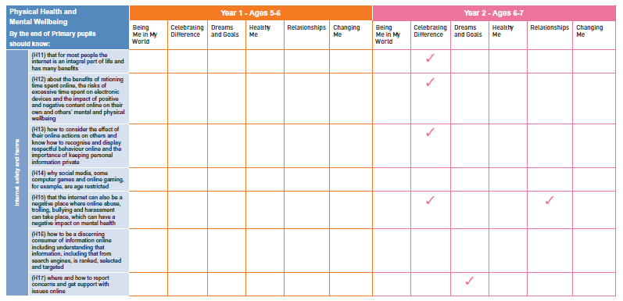

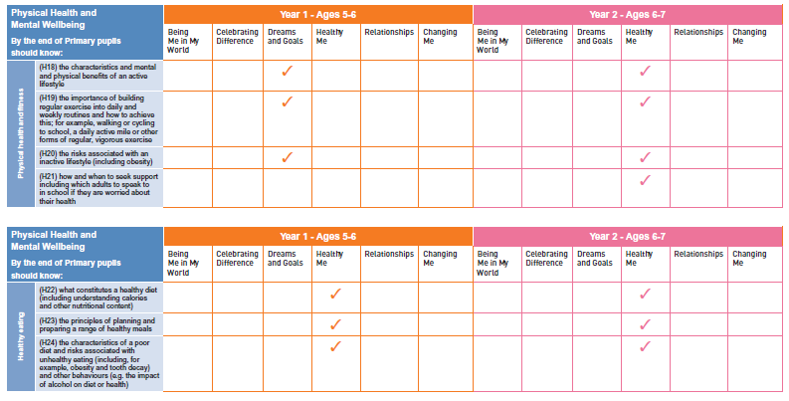

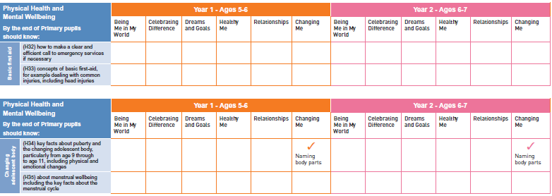

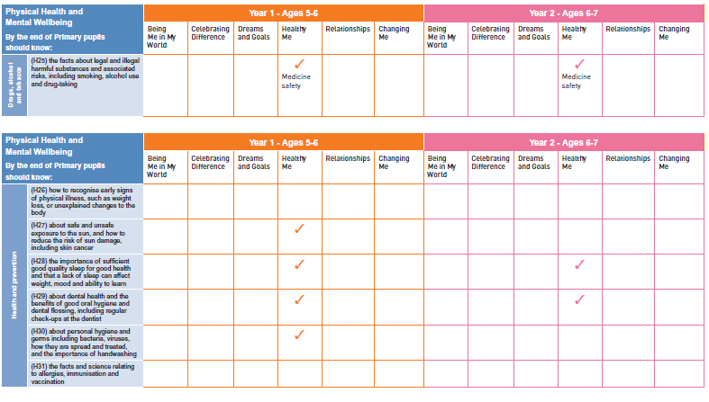

Mapping Health and Relationship Education into our Long Term Plans Keystage 1

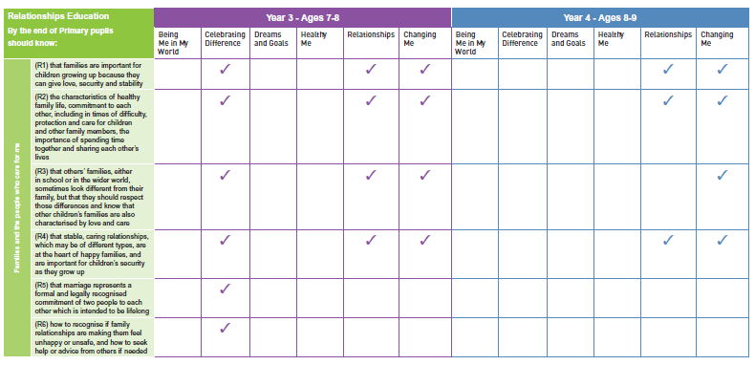

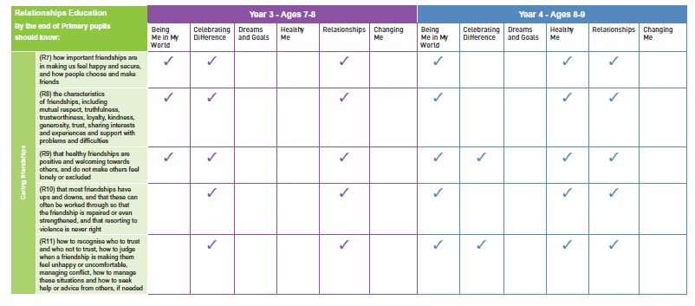

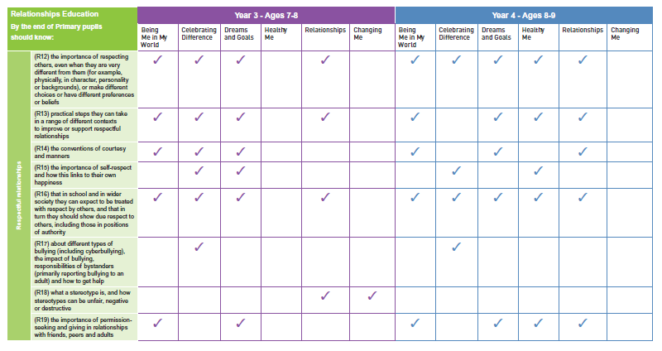

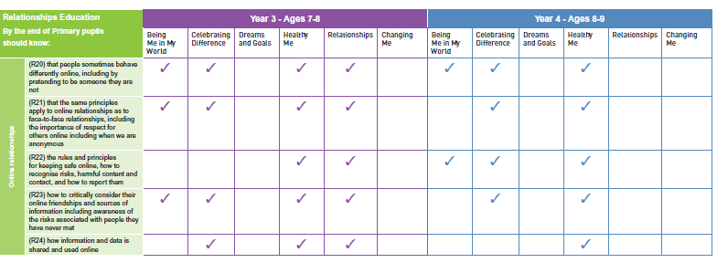

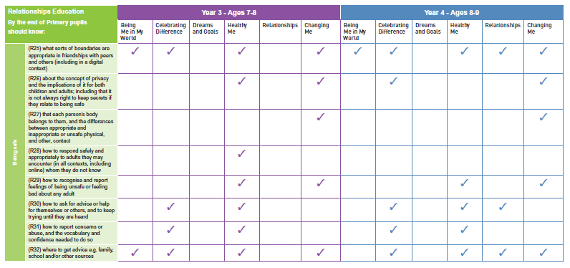

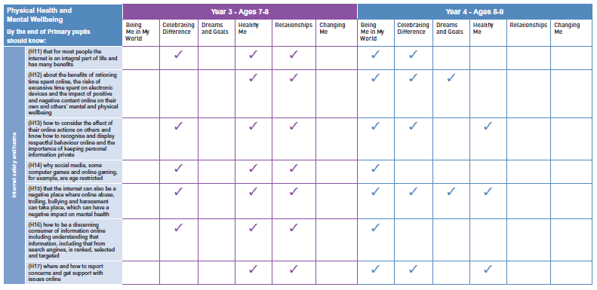

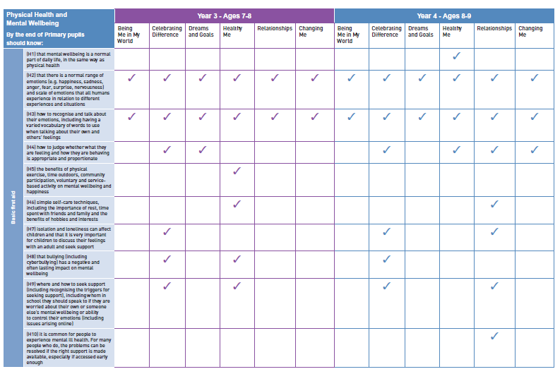

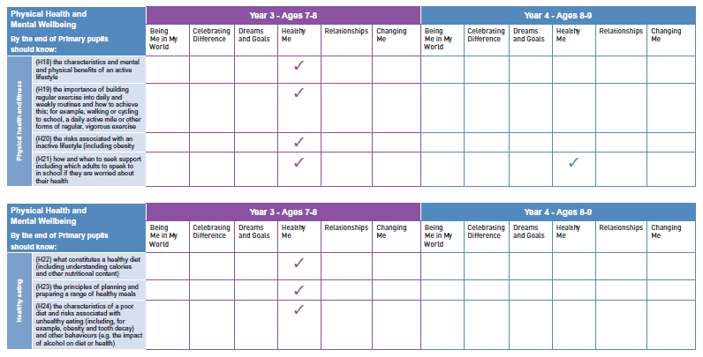

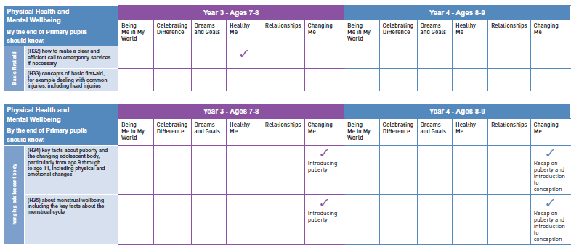

Having met with the middle schools it was decided that:
Areas being covered by the middle school in year 6 replaced with growth and change

Mapping British Vaues.
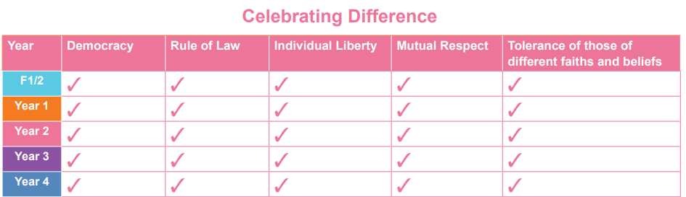
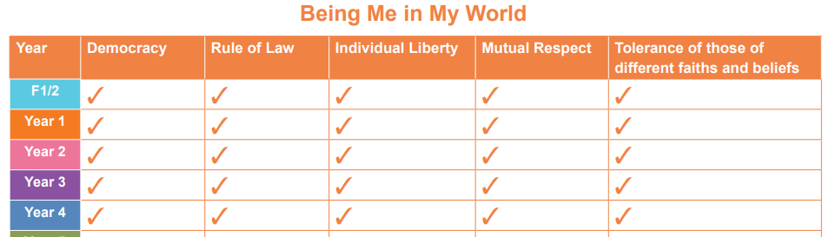

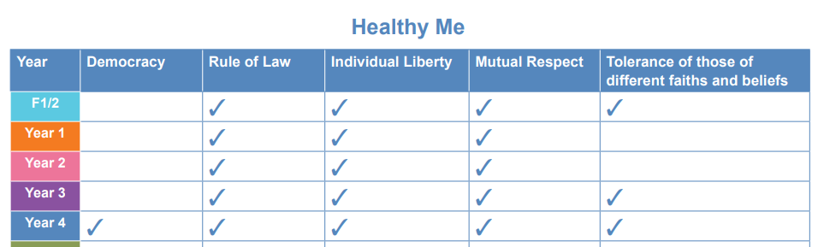
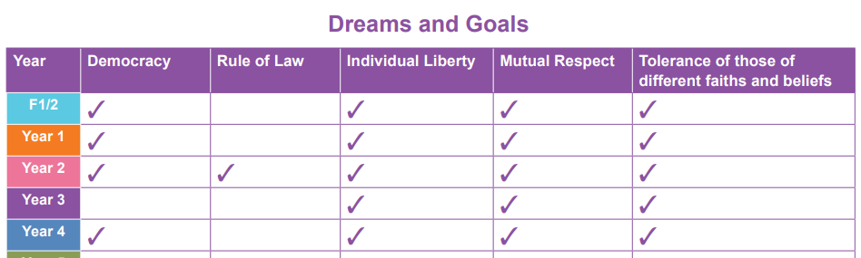

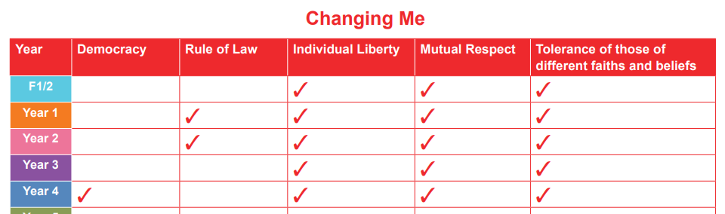
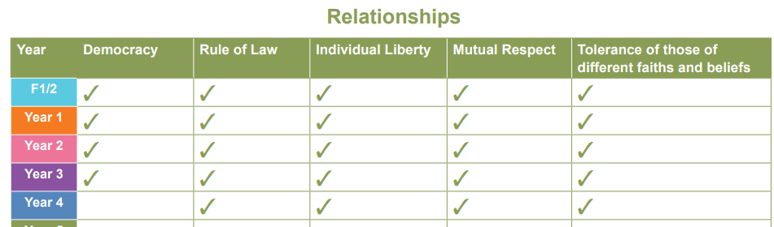

Every lesson from Early Years to year 4 offers opportunities for children’s spiritual, moral, social and cultural (SMSC) development, and this is clearly mapped and balanced across each year group. Likewise, plans are designed to provide structured opportunities in every lesson to practise and enhance the five skills associated with the emotional literacy (self-awareness, social skills, empathy, motivation and managing feelings). At Southridge, we believe that these opportunities are vital for children’s development, their understanding of themselves and others and in increasing their capacity to learn. The following grids give a quick visual reference and summary of where these opportunities sit within Jigsaw
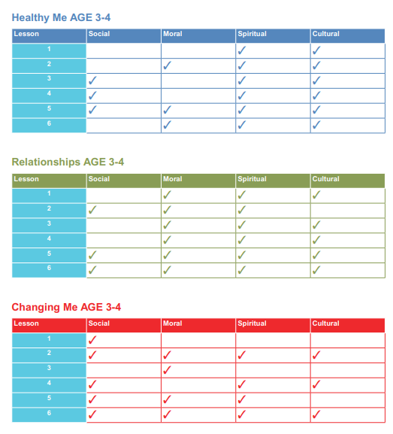
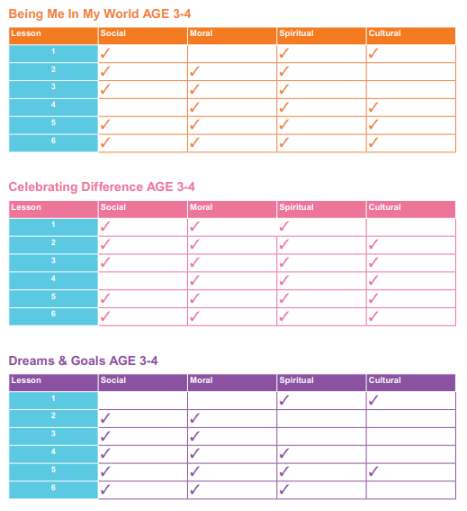

Reception
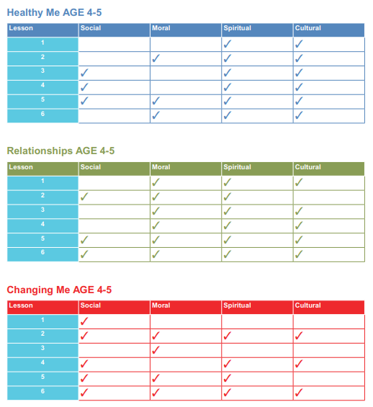
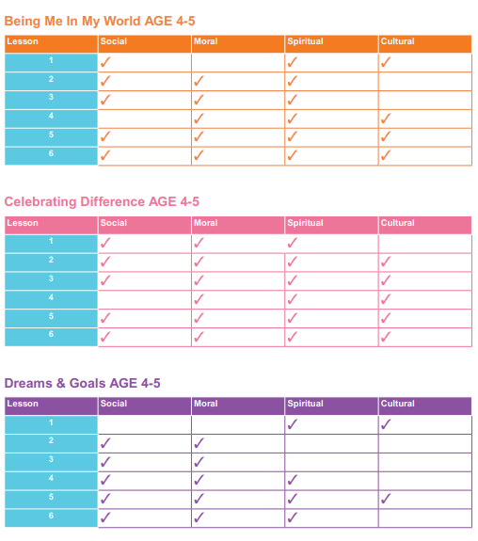

Year 1
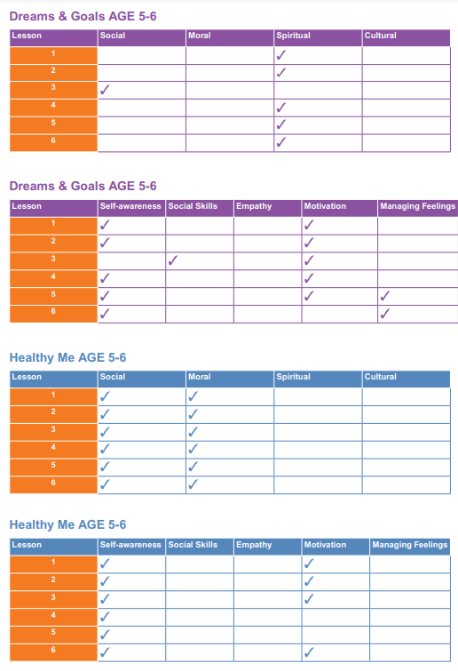
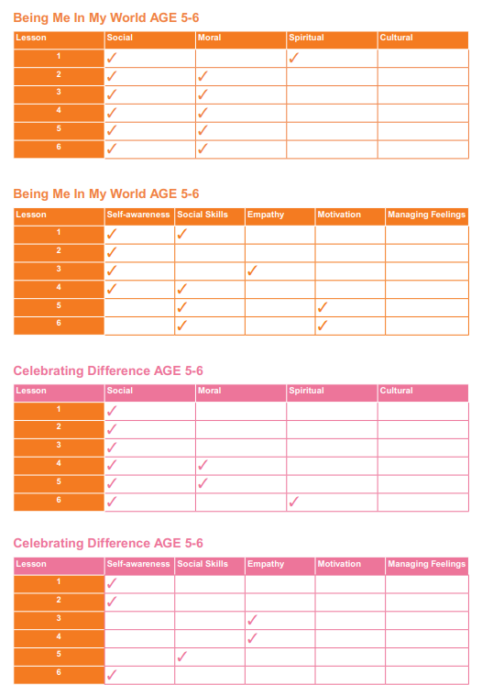

Year 1 continued:
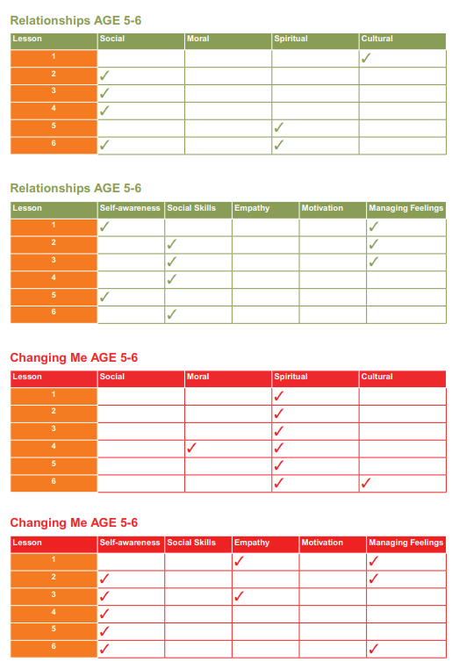

Year 2
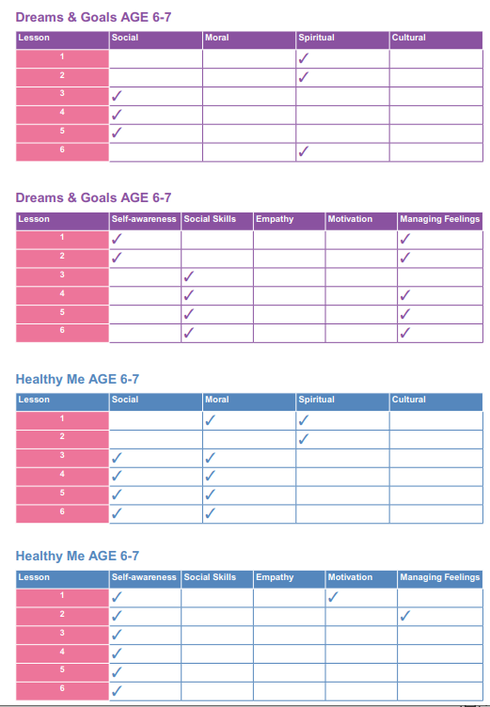
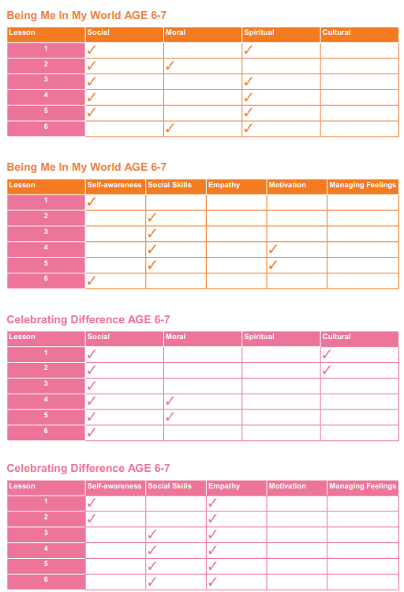

Year 2 continued
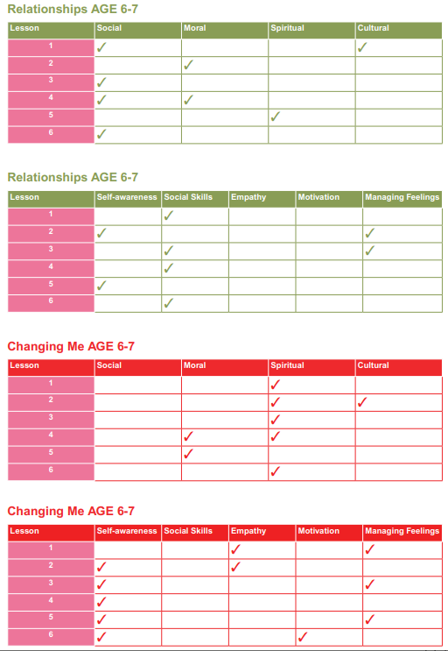

Year 3
:
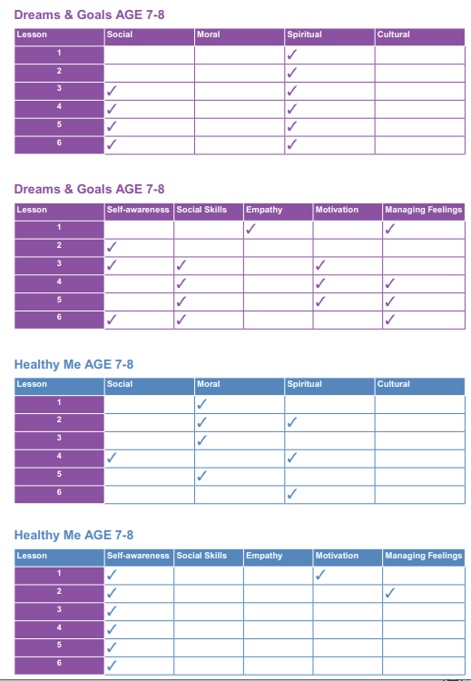
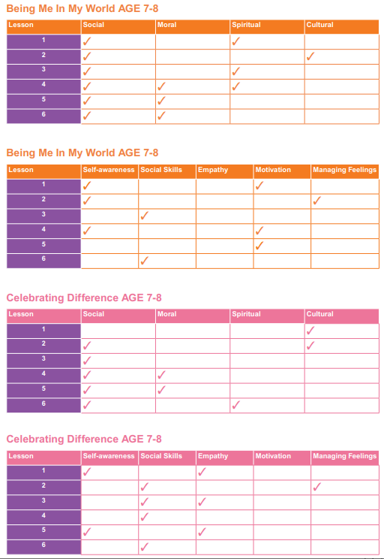

Year 3 continued
:
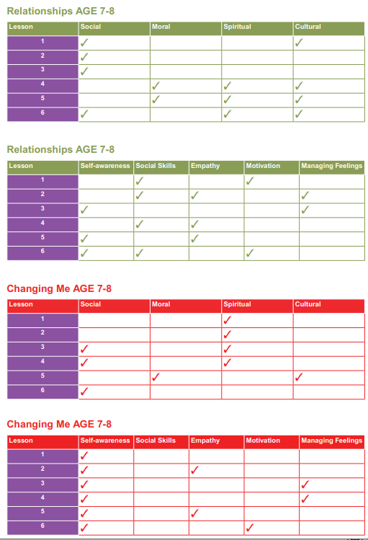

Year 4
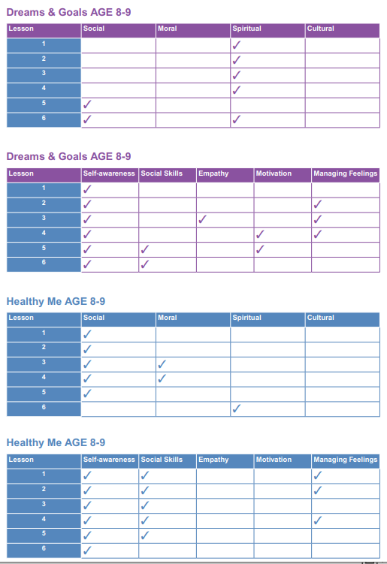
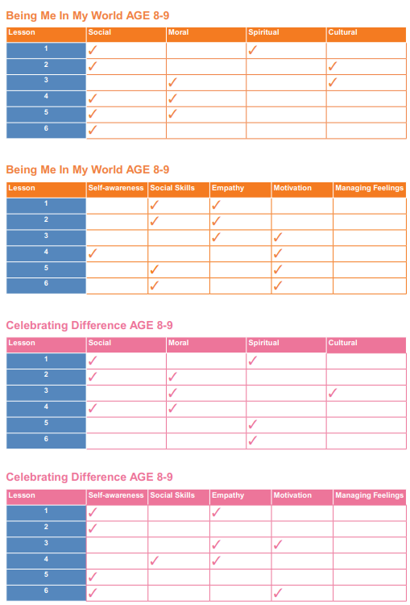

Year 4 continued :

